**Project Statement:**

Build an end-to-end ETL (Extract, Transform, Load) workflow using Azure Data Factory to orchestrate data movement and transformation, and leverage Azure Databricks for complex data transformations using Spark.

**Project Overview:**

**The goal of this project is to build a robust and scalable end-to-end ETL workflow leveraging Azure Data Factory (ADF) and Azure Databricks. This ETL pipeline will facilitate the extraction of data from various sources, transform the data using Azure Databricks with Spark for complex transformations, and load the processed data into a destination storage.**

**Prerequisites:**

* **Azure Subscription**
* **Azure Data Factory**
* **Azure databricks Workspace**
* **Azure Storage Account**
* **Source Data**

**Project Requirements:**

1. Azure data factory components: linked services, datasets, pipelines
2. Azure data bricks components like Workspace, Cluster, Notebook
3. Azure Storage account
4. Integration and Configuration like ADF- Databricks Integration and Authentication.
5. Monitoring and management: monitoring tools, logging and alerting.

**Architecture diagram:**

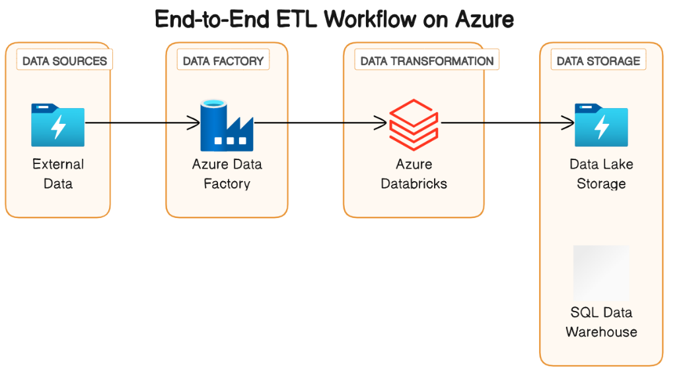

**Tools /Technology used in project:**

* Spark
* Data Lake
* Azure Databricks
* Azure Data Factory
* Azure Date Lake Storage Gen2

**Source Data file:**

The source file is extracted from the GitHub and the URL is provided below:

<https://github.com/Praveenkorupalli/BIBA-data-engineering/blob/main/electronic-card-transactions-november-2023-csv-tables.csv>

**Execution Overview:**

**The execution of this end-to-end ETL workflow involves a series of steps to seamlessly extract, transform, and load data using Azure Data Factory (ADF) and leverage Azure Databricks for complex transformations with Apache Spark.**

**Begin by setting up an Azure Data Factory instance which involves creating a new Data Factory and defining linked services to establish connections with your data sources and destinations. This includes creating connections to Azure Blob Storage or any other relevant data sources.**

**Construct pipelines in the ADF interface to orchestrate the entire ETL workflow. Within each pipeline, incorporate activities such as Copy Data to facilitate the movement of raw data from source to destination.**

**To perform data transformations, integrate Azure Databricks into the workflow by Creating a cluster within your Azure Databricks workspace and develop Spark-based notebooks for complex transformations and also Incorporate Databricks activities within the ADF pipeline to trigger the execution of Databricks notebooks.**

**After the transformations in Databricks, use ADF's copy data activities again to load the processed data into the destination storage or data warehouse.**

**Implementation Steps:**

1. **Setup Azure data factory:**

* **Create a data factory**
* **Configure linked services**
* **Create pipelines**
* **Setup Triggers**

1. **Setup Azure Databricks:**

* **Create a databricks workspace**
* **Mount Azure storage**
* **Develop spark notebooks**
* **Test spark code**
* **Create and Schedule jobs**

1. **Integrate ADF with ADB**

* **Create databricks linked service in ADF**
* **Use Databricks Activities in ADF pipeline**
* **Debug and Monitor**

1. **Schedule and Monitor**

* **Scheduling**
* **Logging and Monitoring**
* **Error handling**

**By following the above steps, we can have a successful implementation of an End-to-End workflow using data factory and databricks by enabling data extraction, transformation, and loading in a cloud environment.**

**Practical Implementation on Azure Portal:**

**Step1: Setting up the Storage account and Azure Data Factory**

* **To perform the project, firstly login to the Azure portal with the credentials given.**

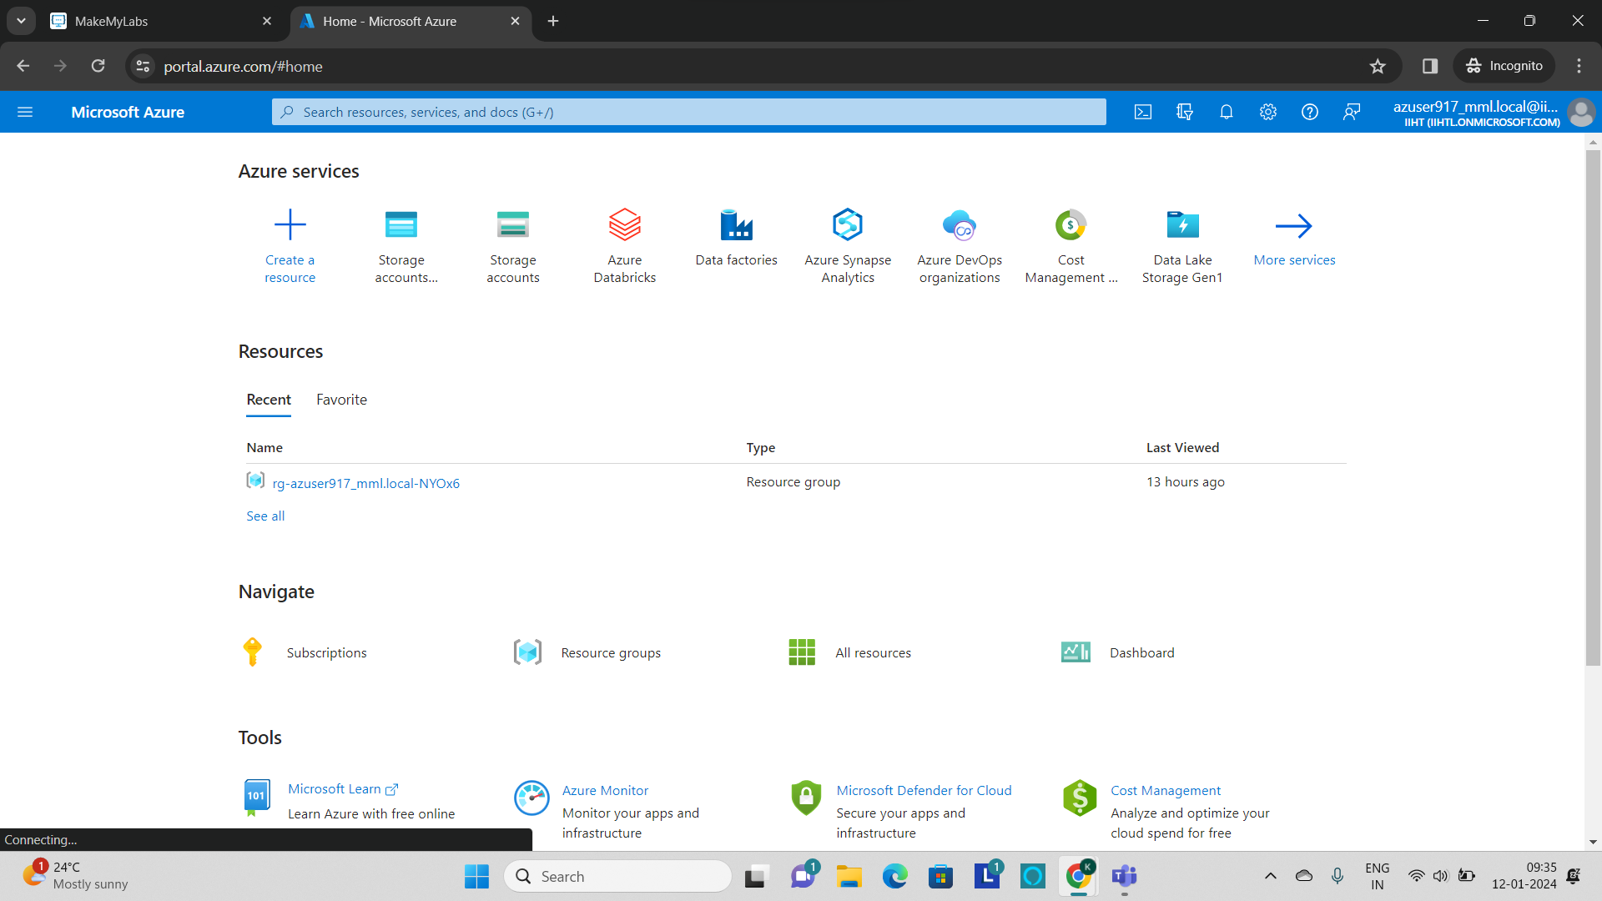

* **As a first step, create a storage account for the source file to be stored.**
* **To create click on Storage account and the storage account page will be displayed.**
* **Click on ‘+’ to create.**

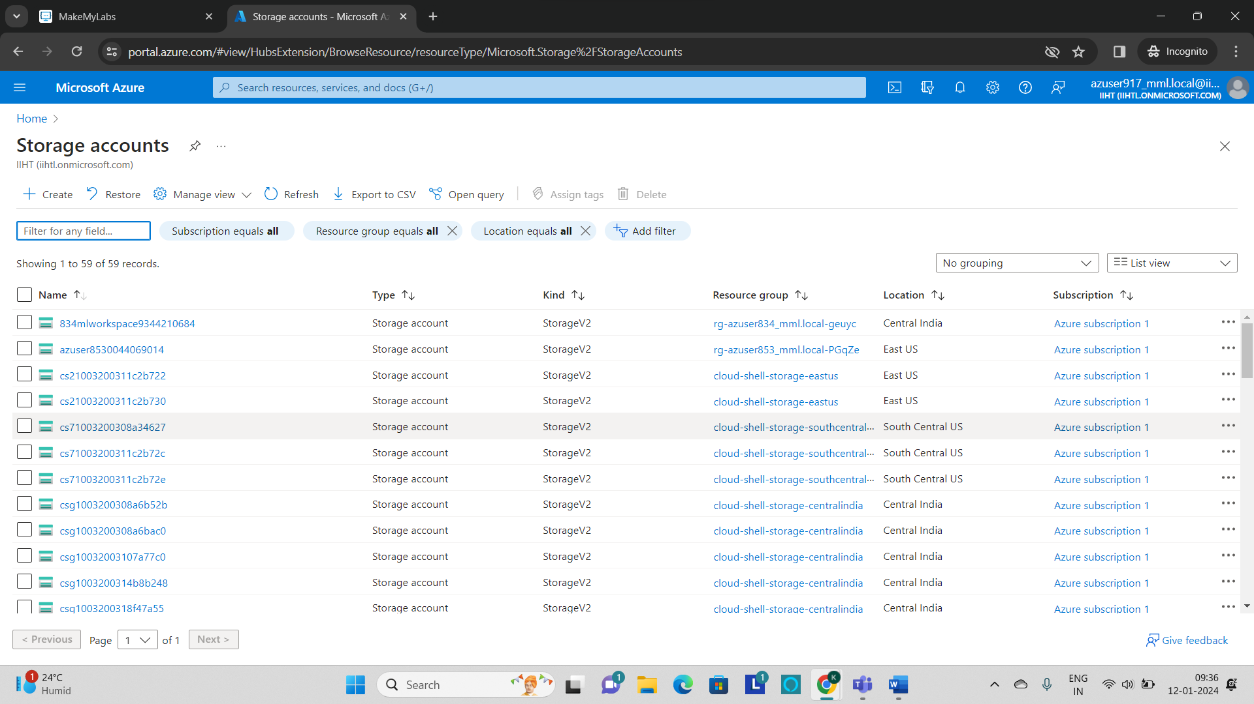

* **Give the basic parameters like resource group, storage account name and then click on “Review”.**

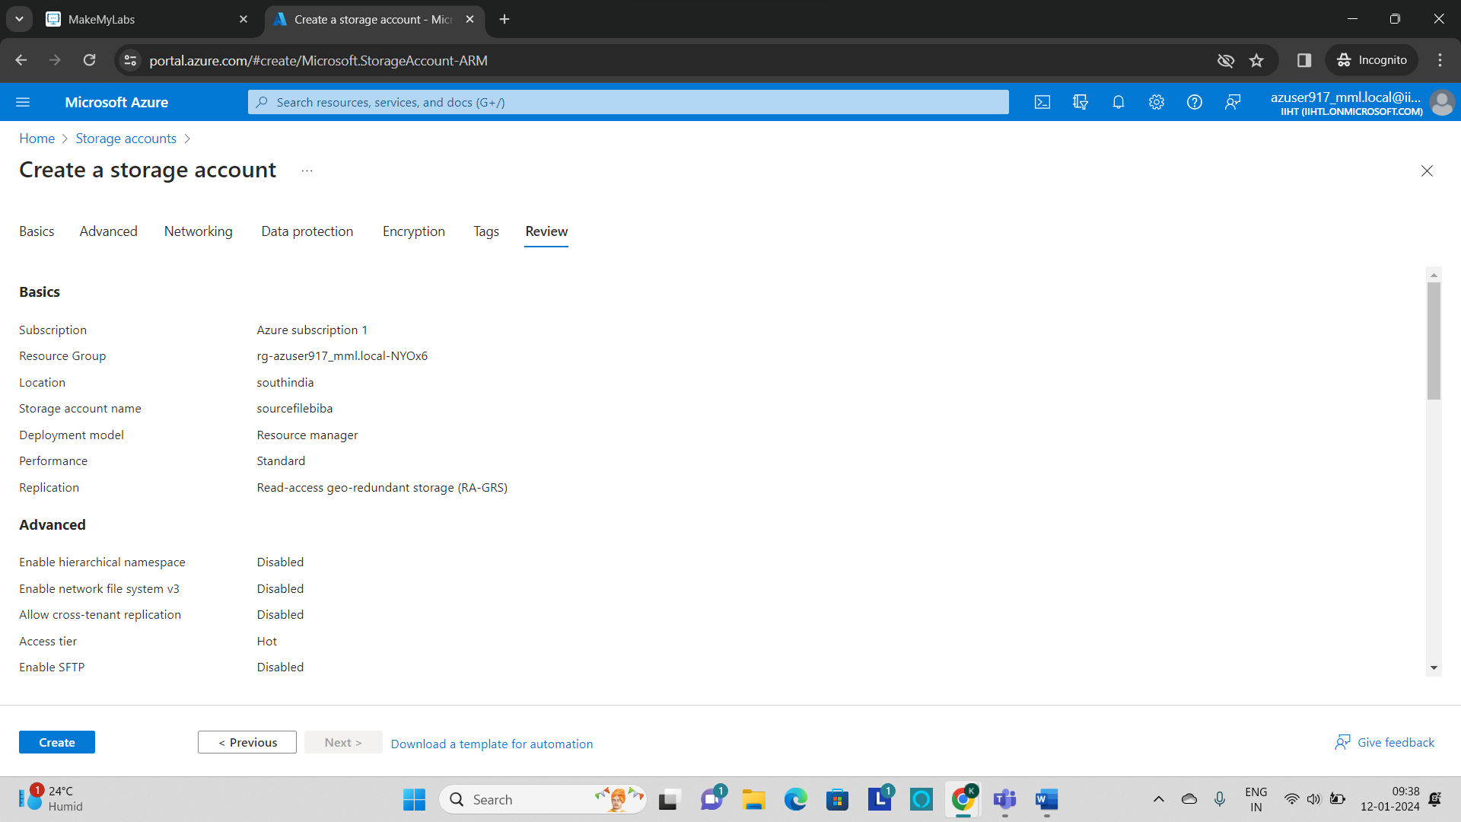

* **If the validation succeeded, then click on “create”.**
* **Deployment will be started and after some time the resource will get created.**

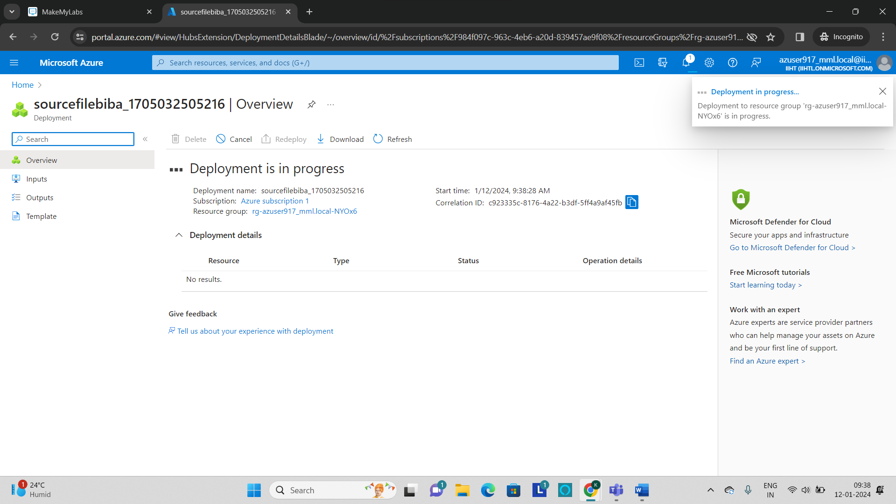

* **After the successful deployment, click on “go to resource” which will be redirected to the storage account.**

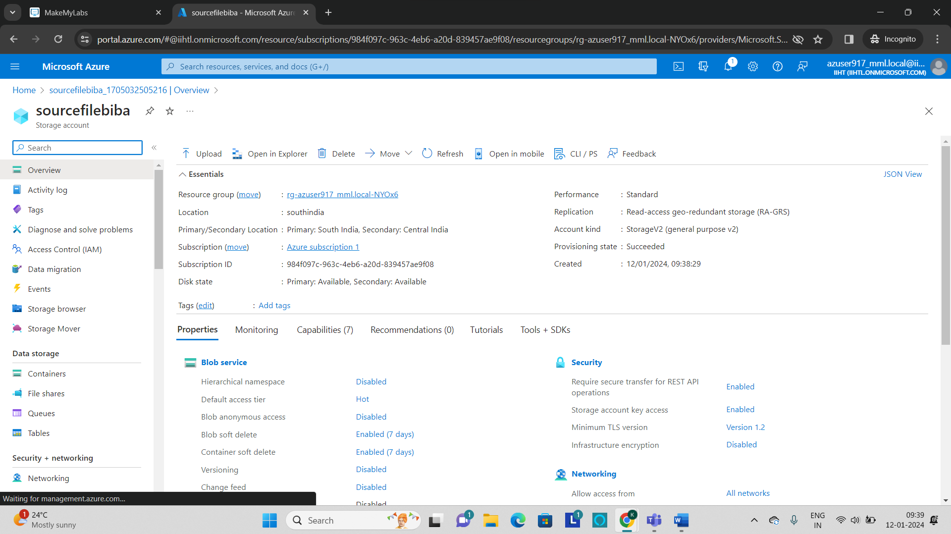

* **The storage account named “sourcefilebiba” has been created.**
* **Go to containers and click on “+container” to create a new container.**

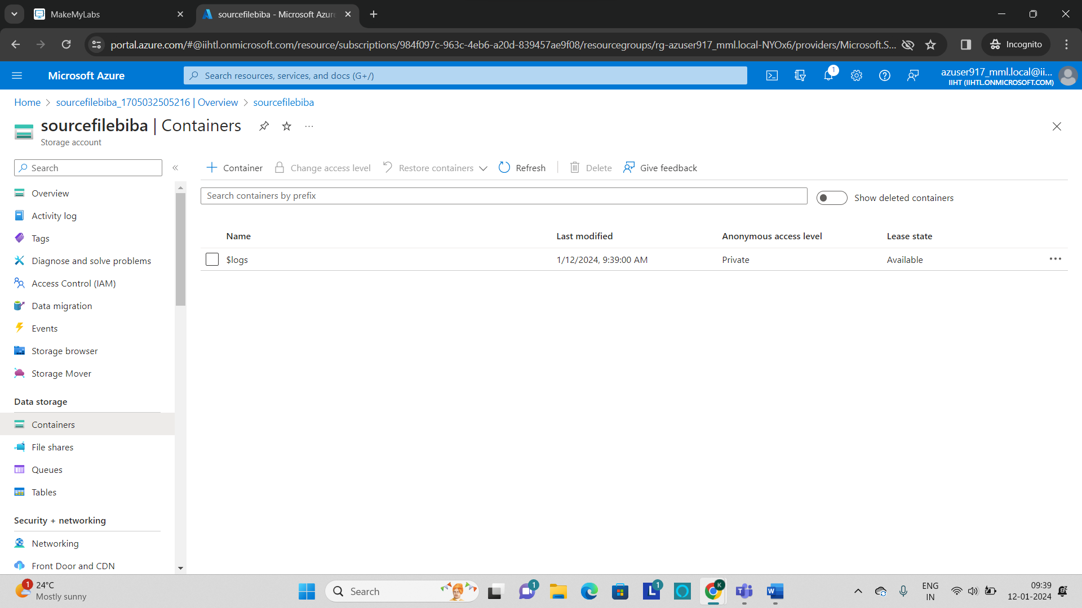

* **Provide the container name and click on “create”.**

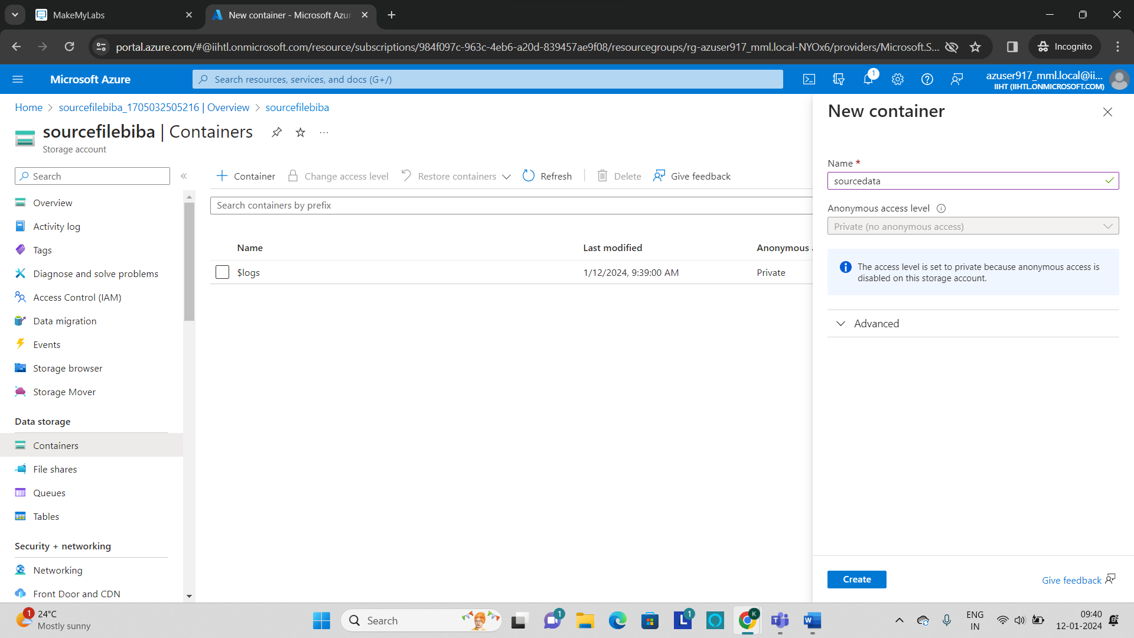

* **The container named as “sourcedata” will be created.**
* **Now as a next step, click on “data factories” and create a new data factory.**

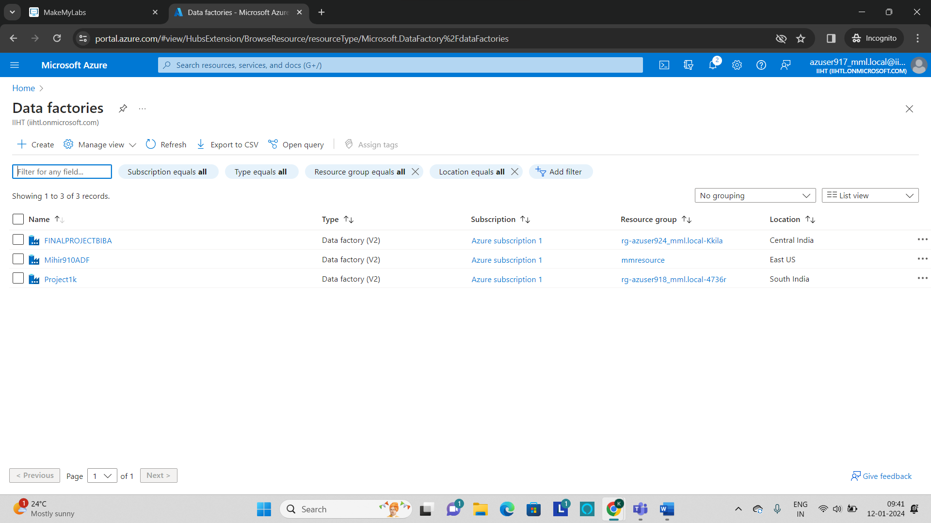

* **Provide the necessary Instance details like name and region to create a data factory.**

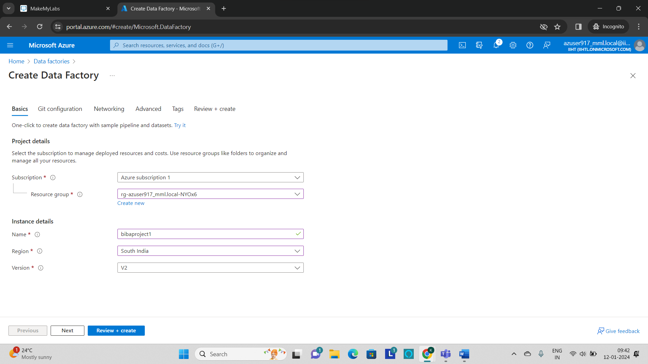

* **After validating all the configurations, click on “Review + create” which will start deploying and after the successful deployment, the azure data factory will get created.**

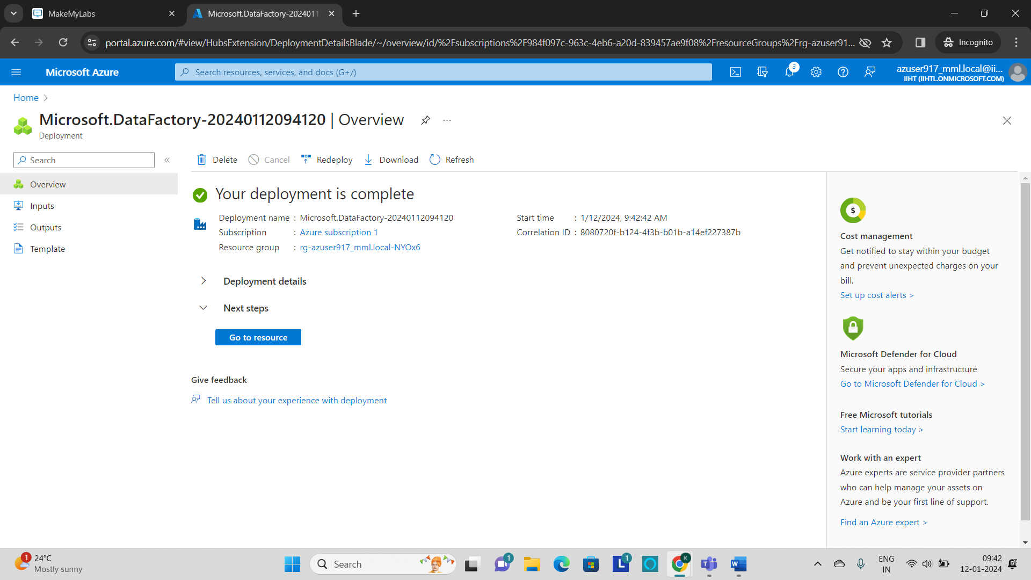

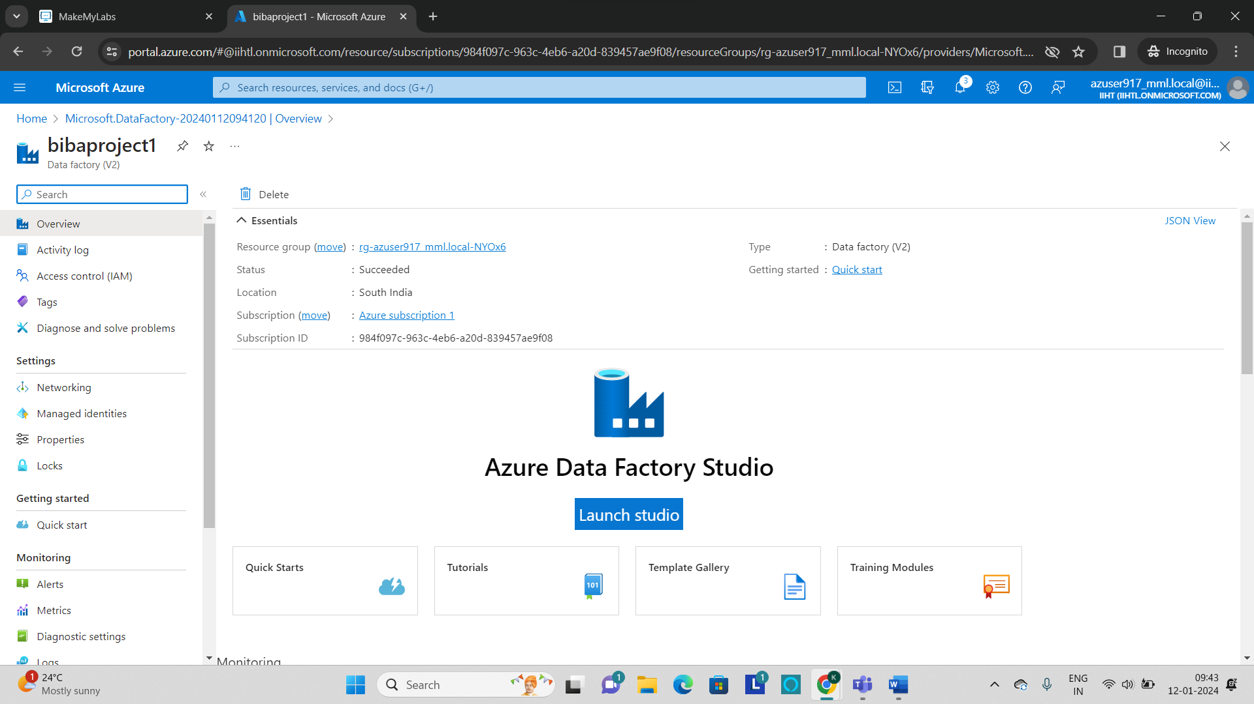

* **Click on “Launch Studio” to open the data factory.**
* **The data factory Interface will be displayed as shown below.**

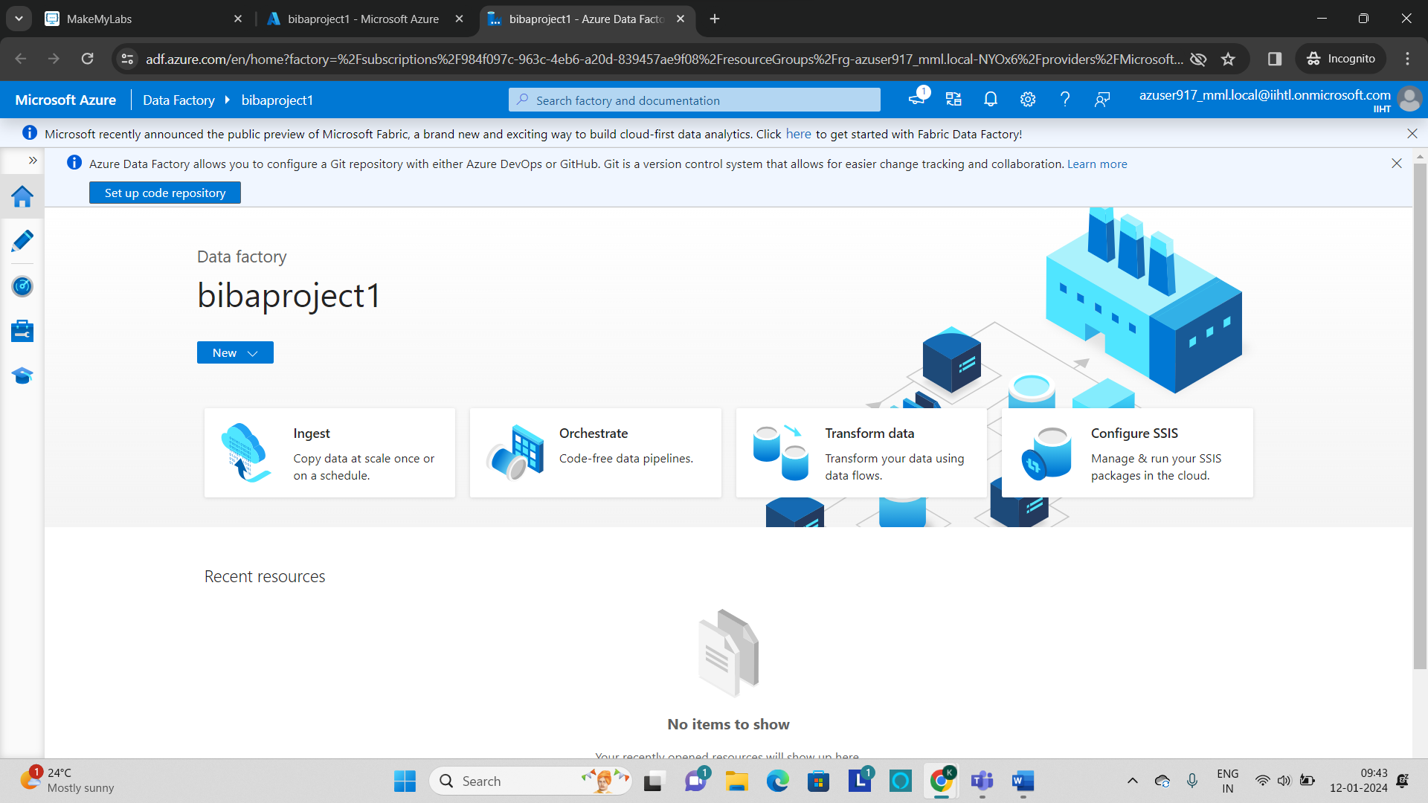

* **Now click on “Author” tab to create a pipeline.**

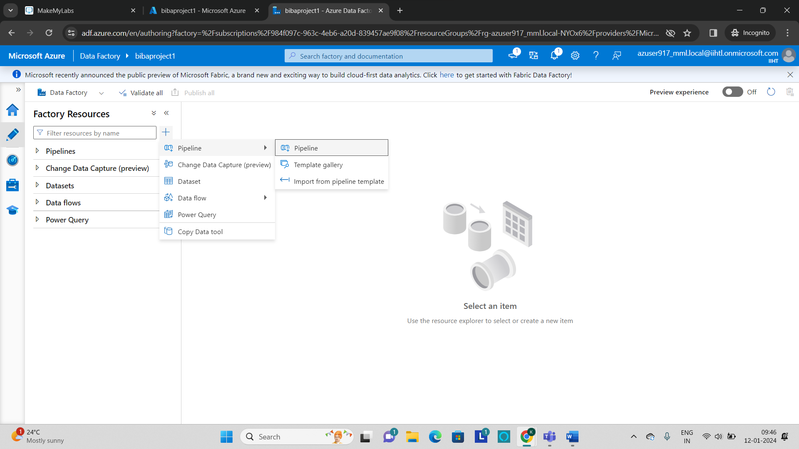

* **After entering into the author tab, click on + to create a new pipeline.**
* **Once the pipeline is created, now include the copy data activity which is located under the Activities Section.**
* **Drag and drop the copy data to the pipeline workspace.**
* **The copy data activity is used to extract the source file from the GitHub and store it in the storage account which is created in the previous.**

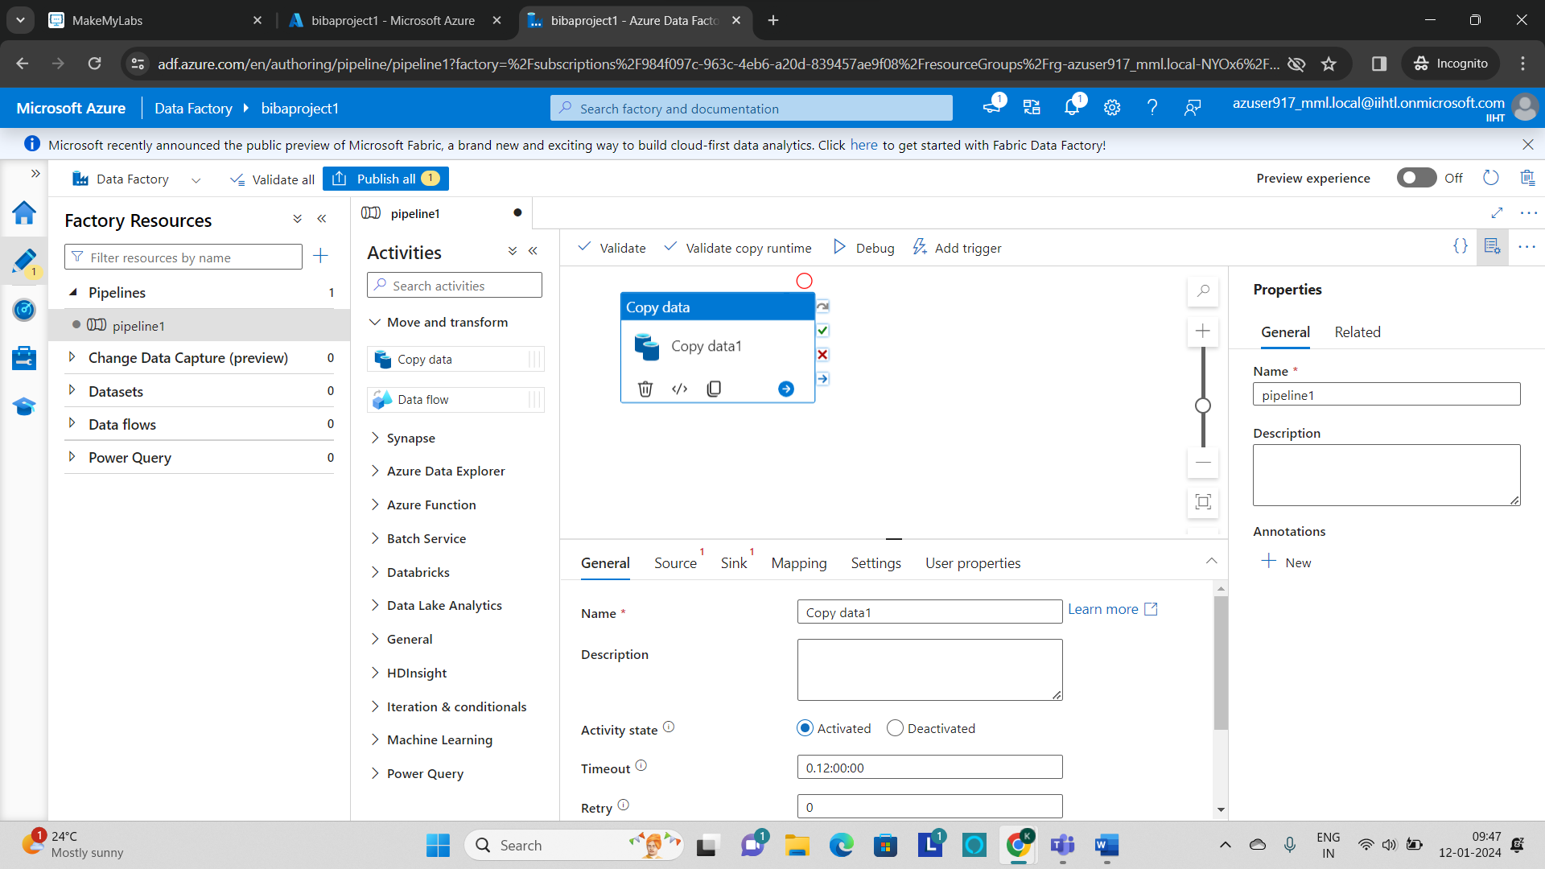

* **After creating the copy activity, give the name as “Ingest” and define the path for the source by selecting the data store as HTTP and click on continue.**

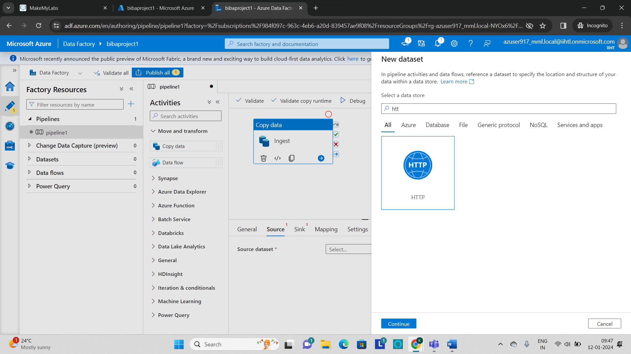

* **Select the format of the file as Delimited Text which is the csv file.**

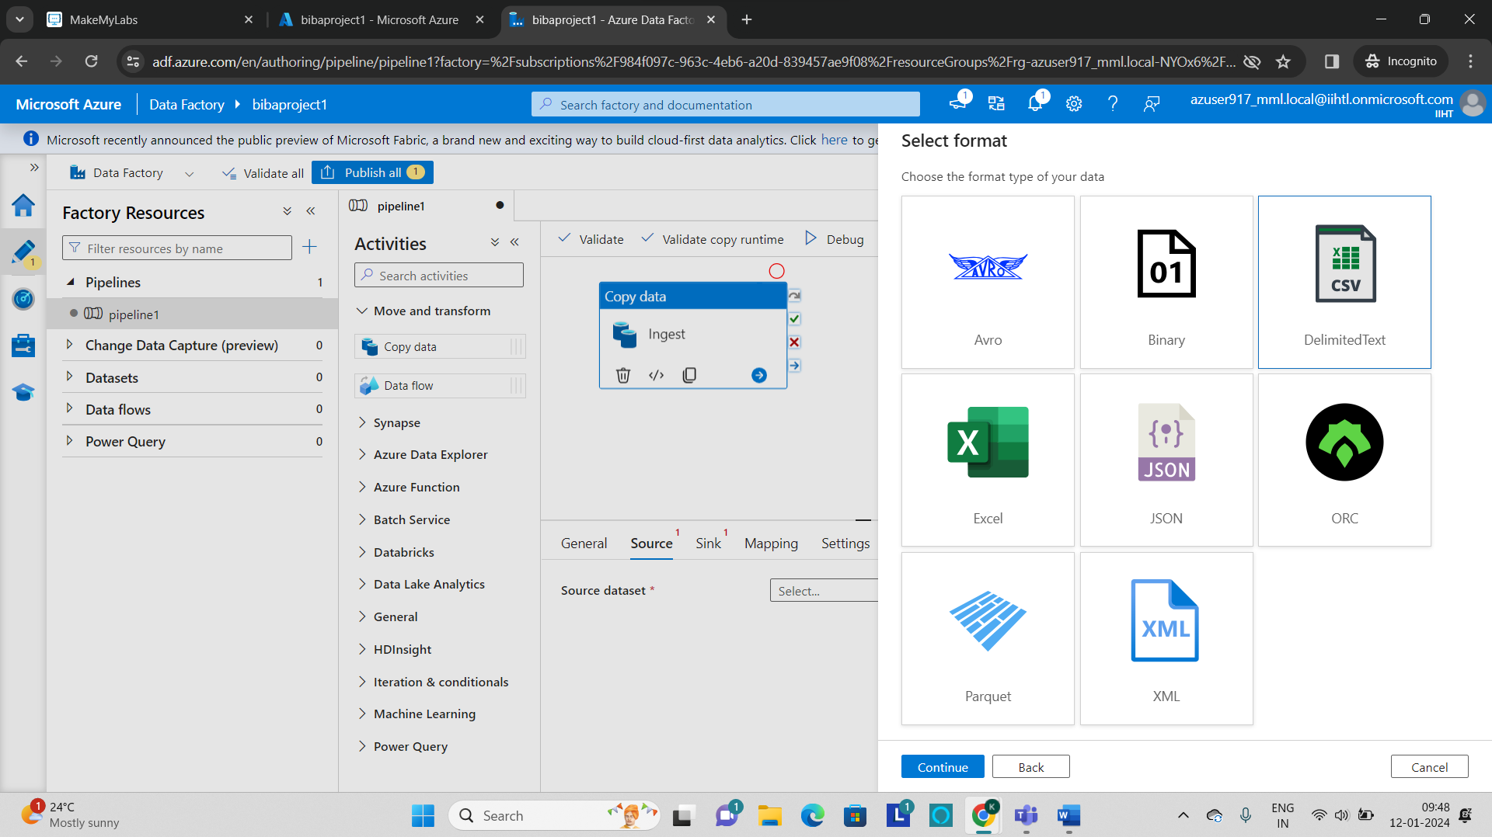

* **Now provide the base URL and Authentication type as anonymous.**

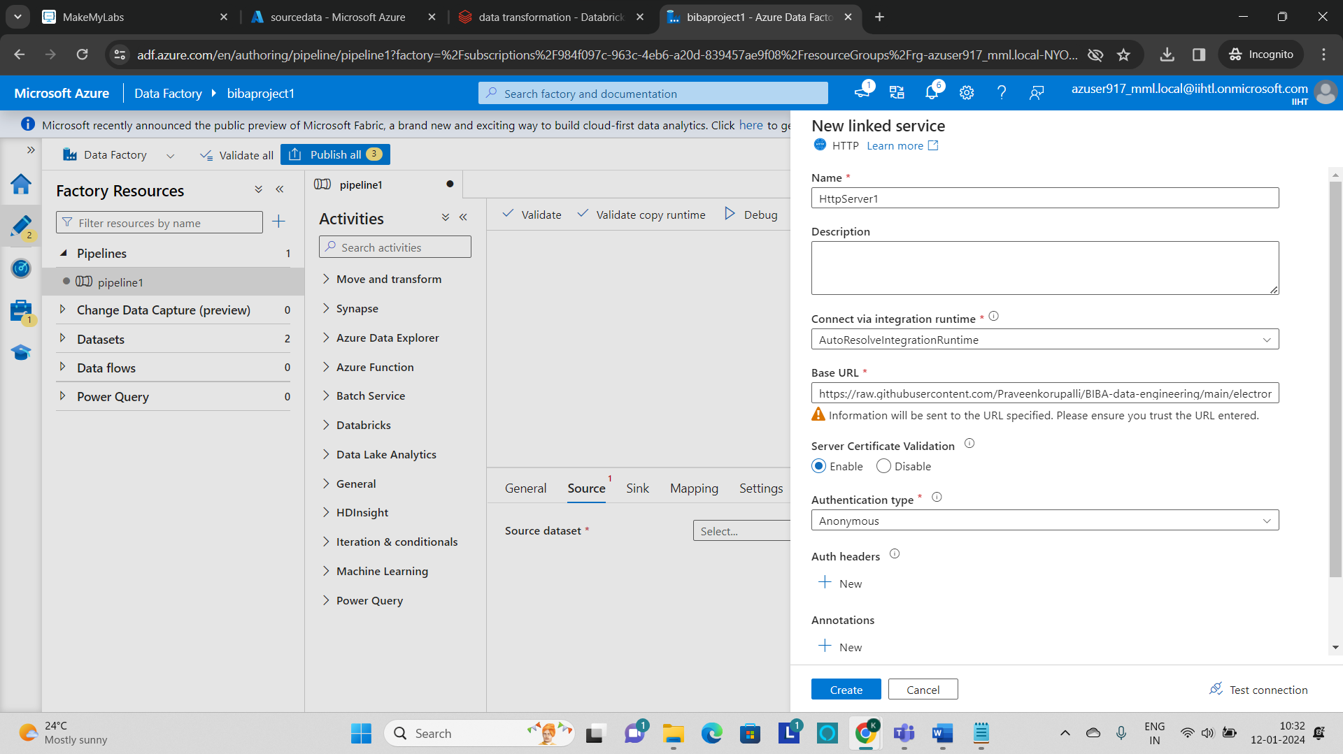

* **Click on create and this will create a linked service.**
* **In the next step we can set the properties as required or leave it as it is.**

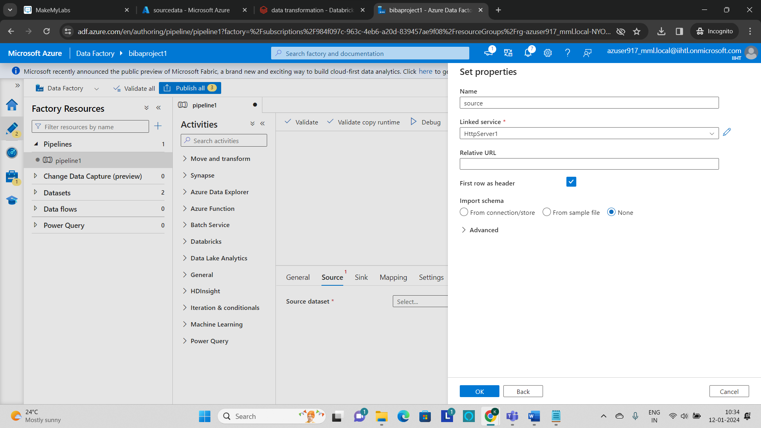

* **After the source data is defined, its time to define the sink where the file has to get stored to perform that click on sink and select a data store as “azure blob storage”.**

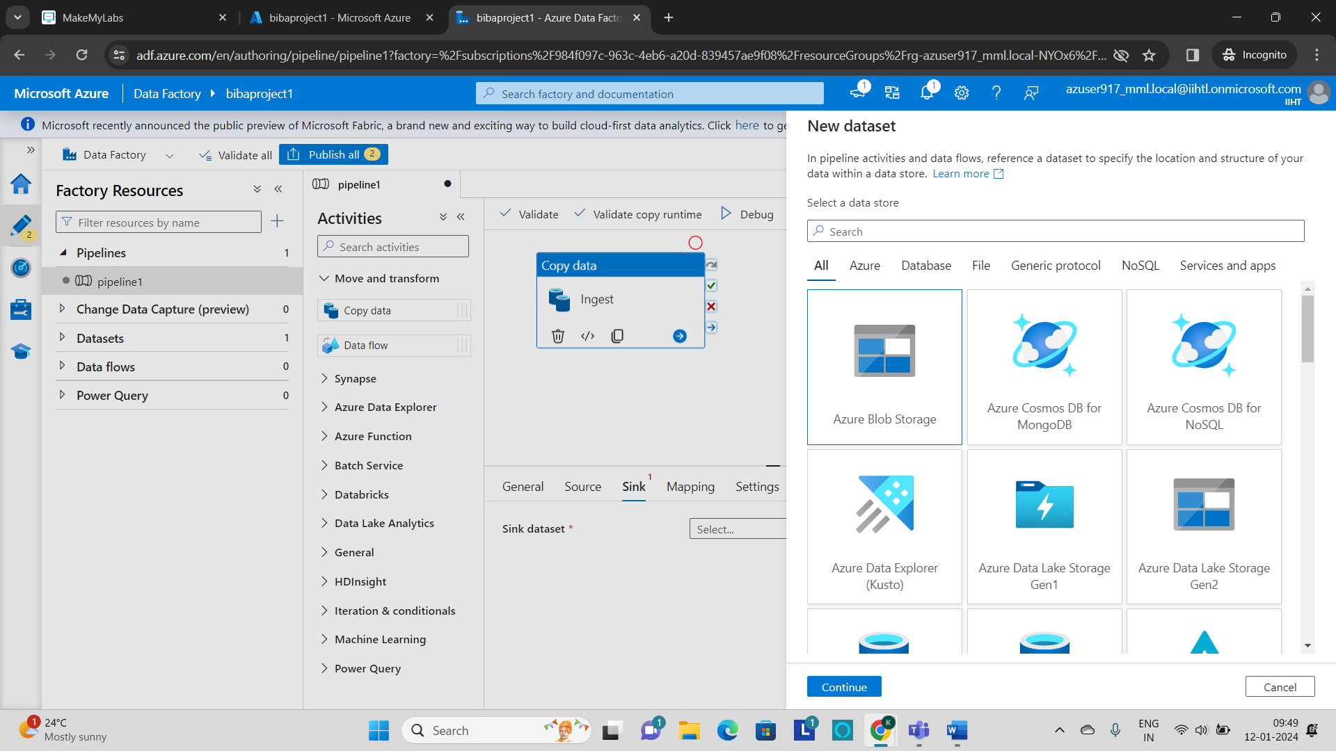

* **Select the format of the file to be stored.**

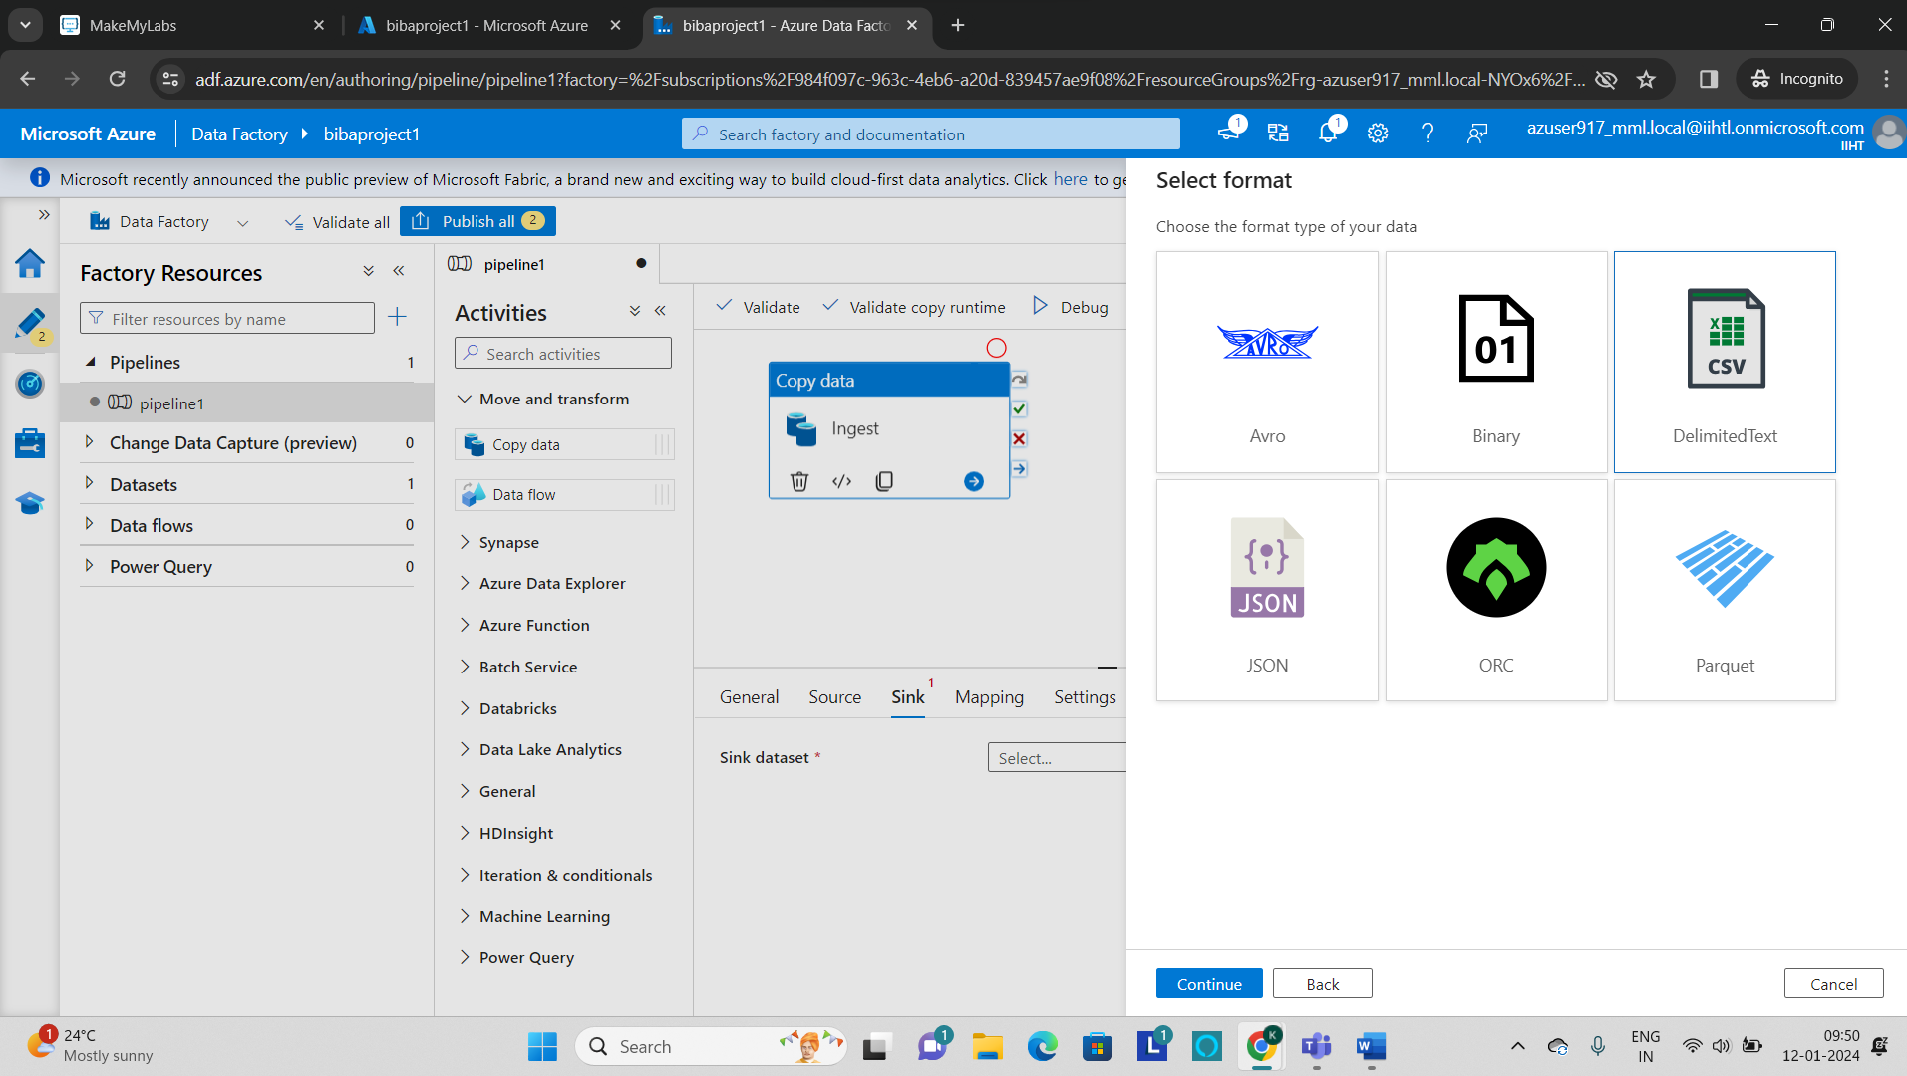

* **Now create a linked service for the azure blob storage by providing the azure subscription and storage account name which you have created previously.**

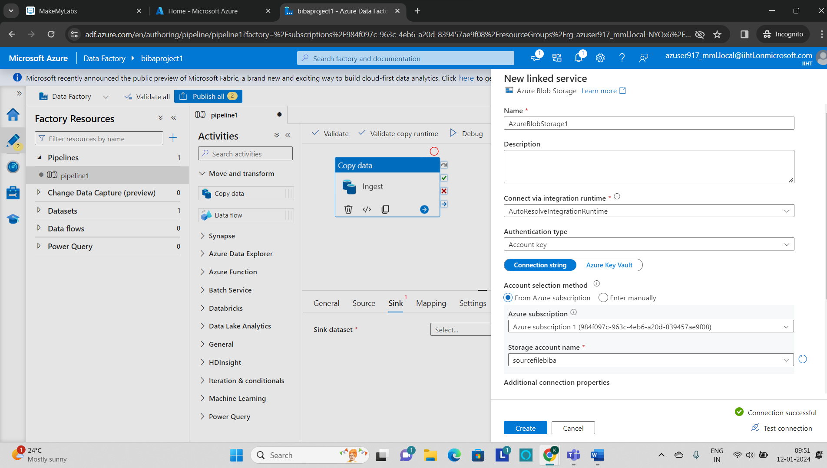

* **Now in the properties section set the file path where to store the data.**

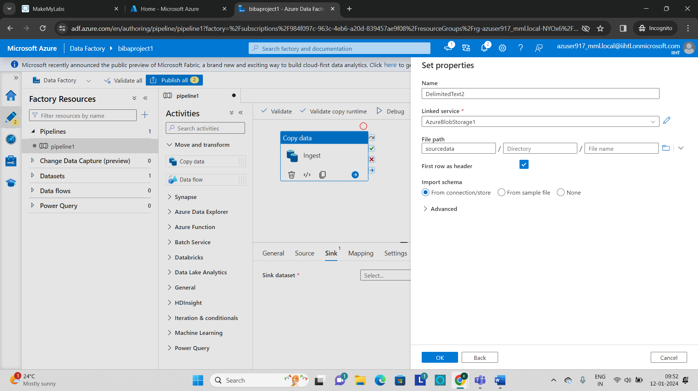

* **Now publish all the changes that are made in the azure data factory.**

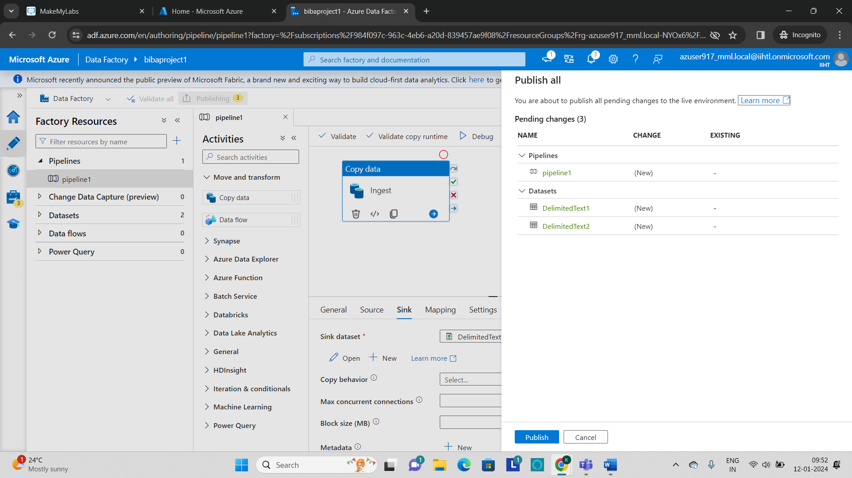

* **Now add a Trigger to the copy activity and to perform this click on Trigger and select “new”.**

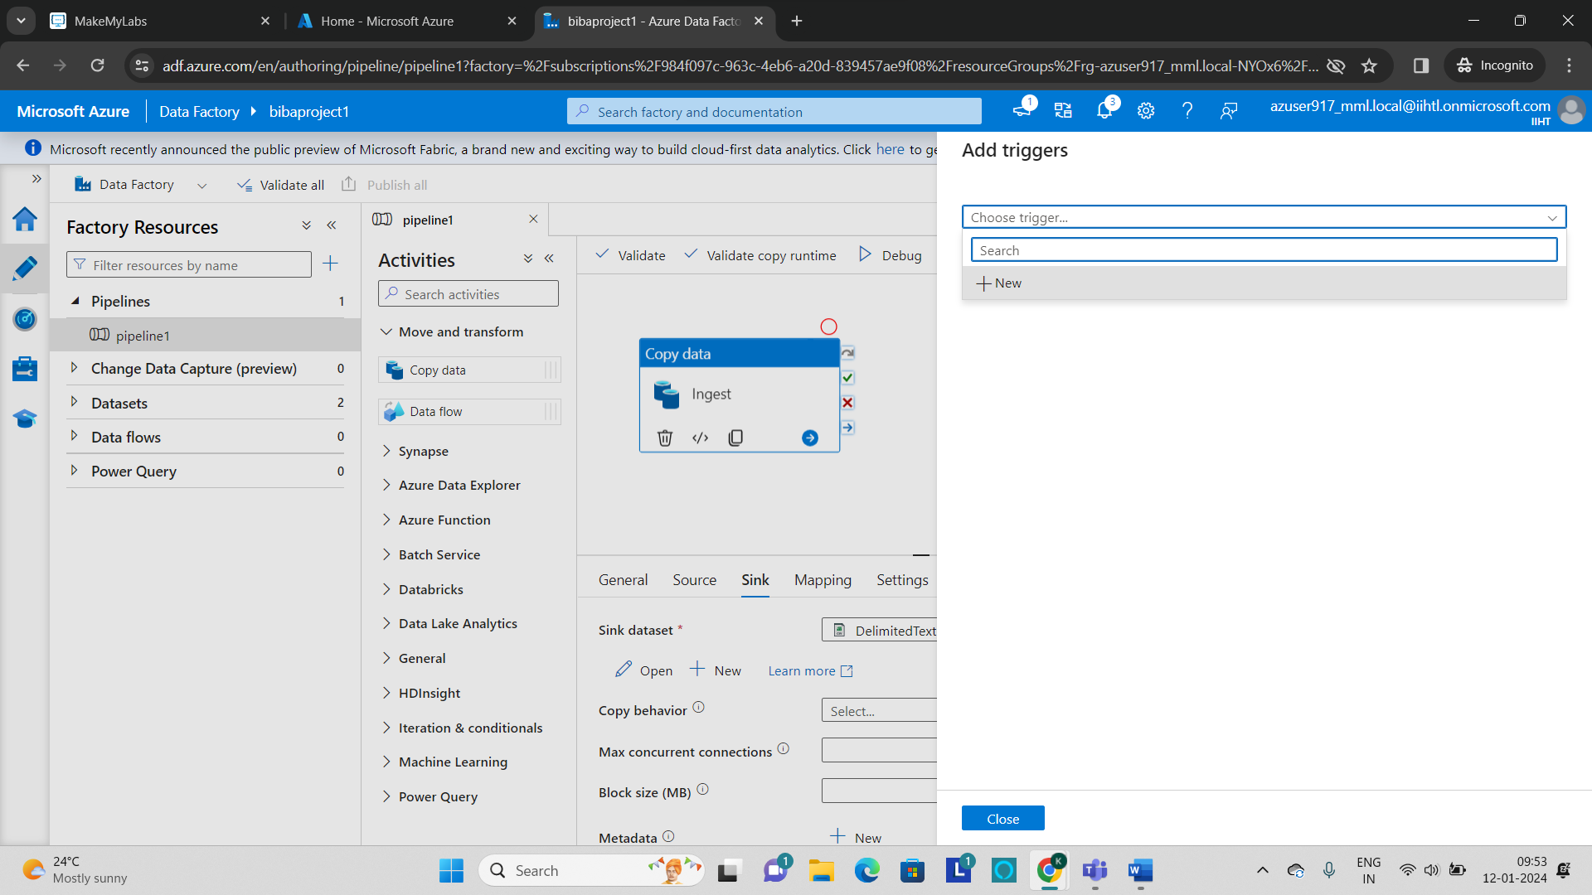

* **We can specify the Name and Type of the trigger as per the requirement.**

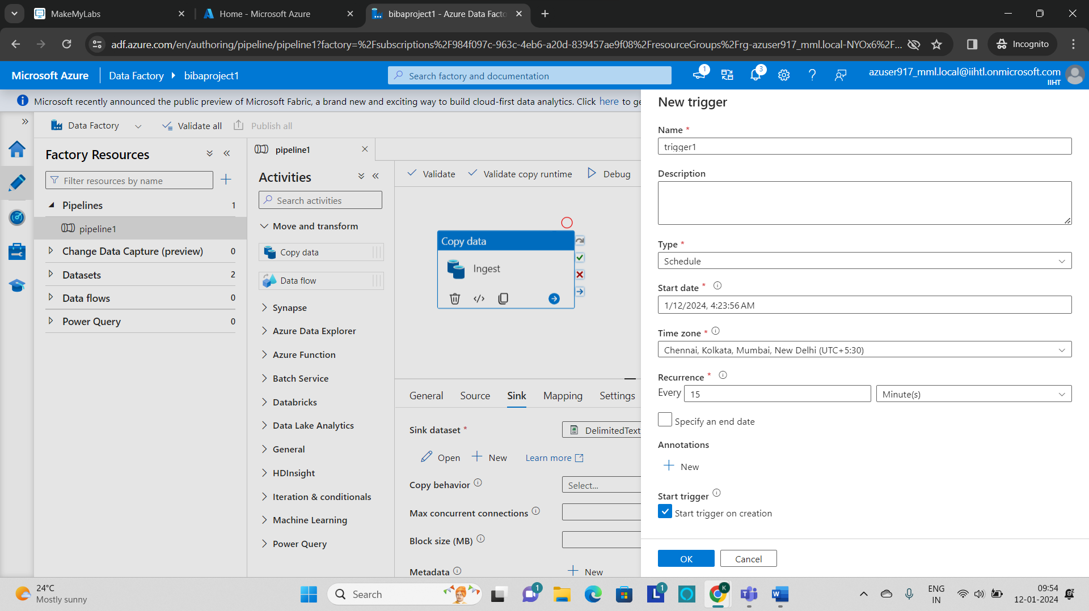

* **After the successful creation of trigger make sure to publish the trigger.**

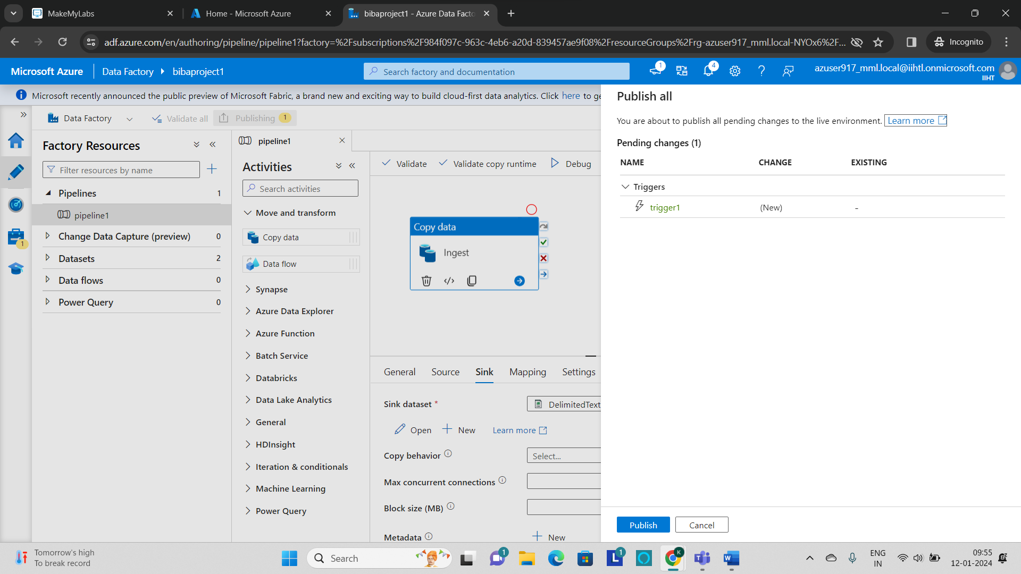

* **Now click on validate to check if the pipeline has any errors.**

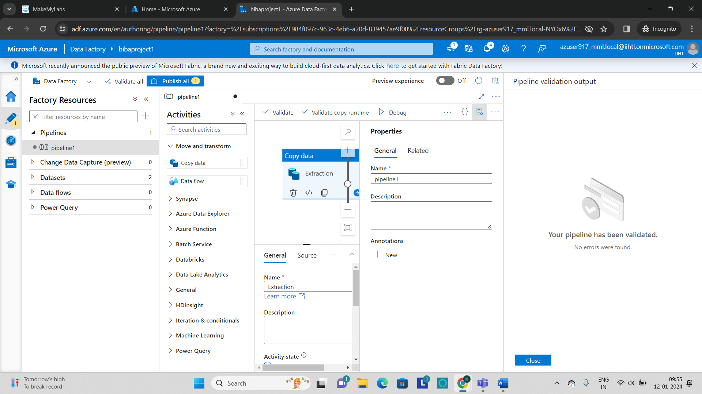

* **If there are no errors in the pipeline, debug and run the pipeline.**
* **We can monitor the status of the pipeline in the output section.**

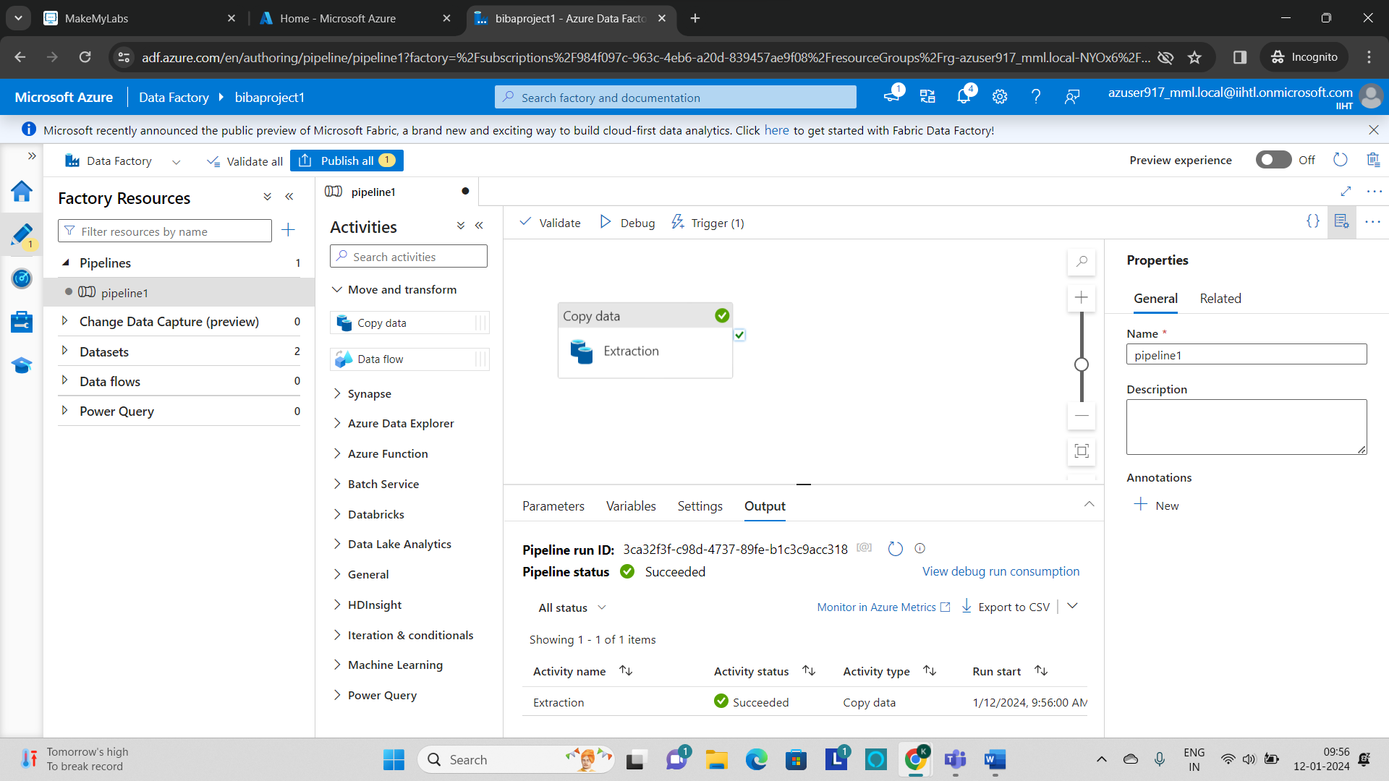

* **The pipeline gets succeeded as shown in the activity status.**

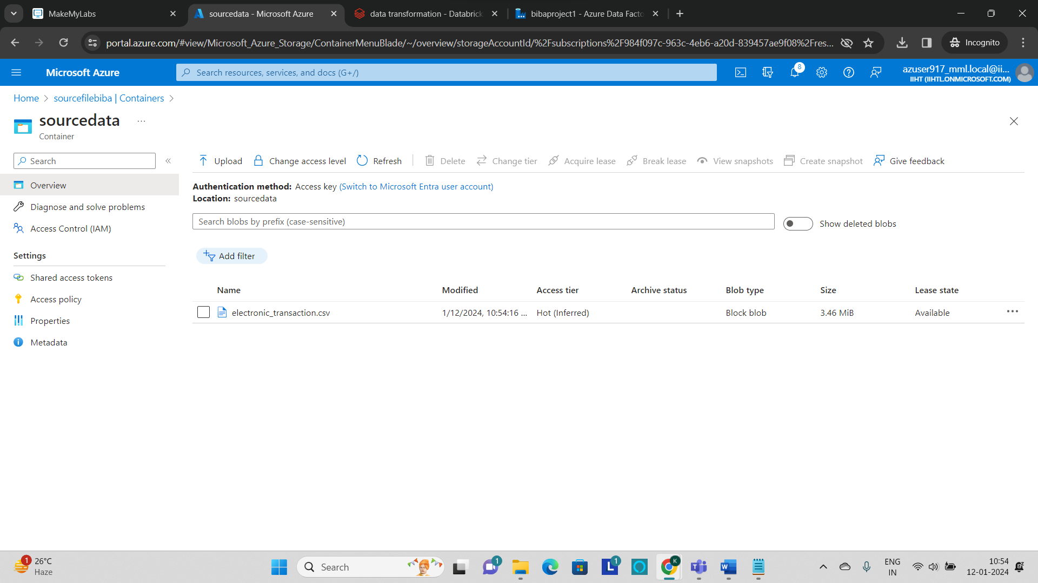

* **To verify that, go to the storage account and see that the file is stored in the container or not.**
* **The file is stored in the container and by this the extraction process has been completed.**

**Step 2: Setup of Azure databricks and transforming the data**

* **Go to azure home page and select the Azure databricks.**

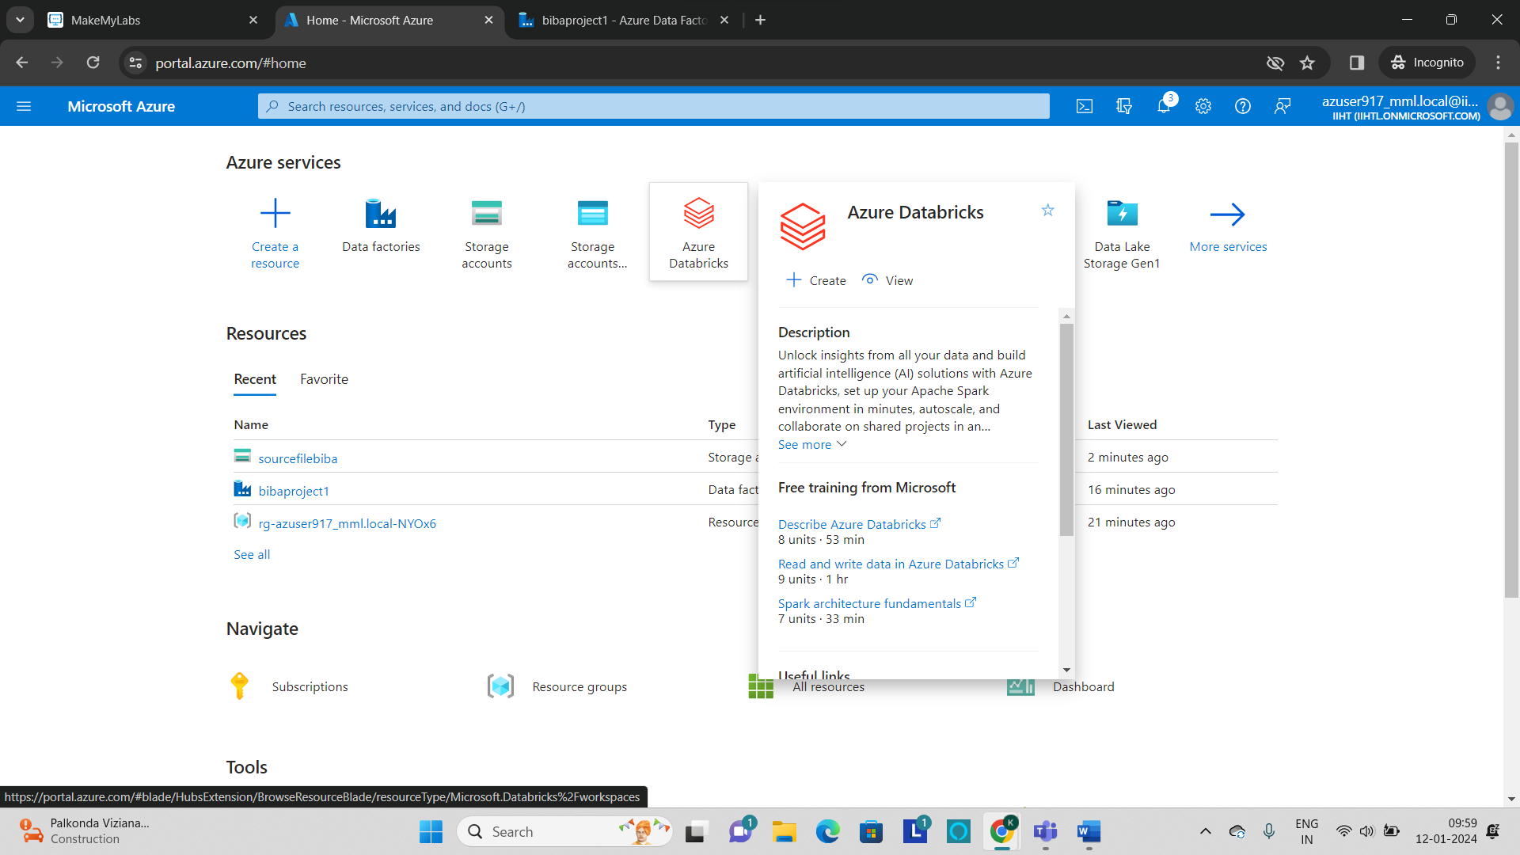

* **Click on Create to create an Azure databricks workspace.**

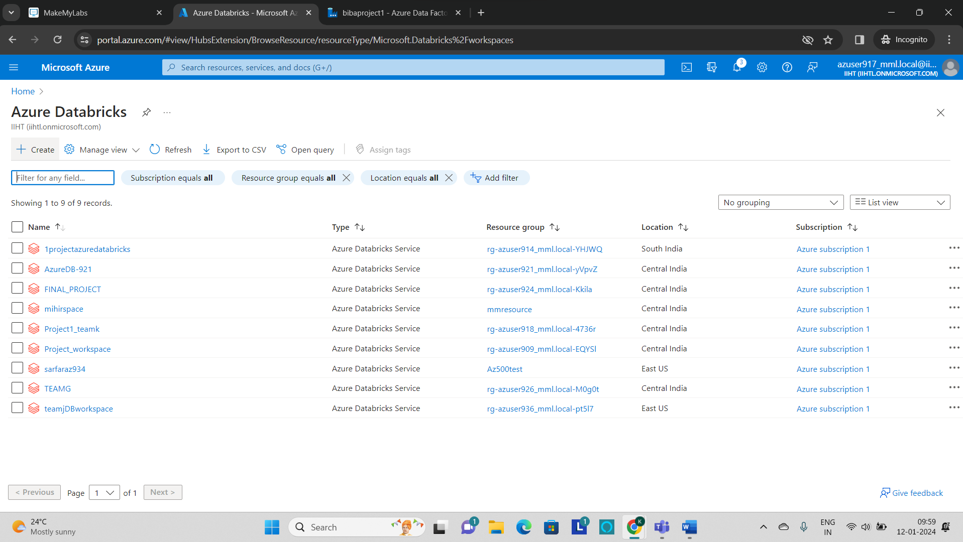

* **Fill out the required parameters such as resource group, name and region and click on Review+create.**

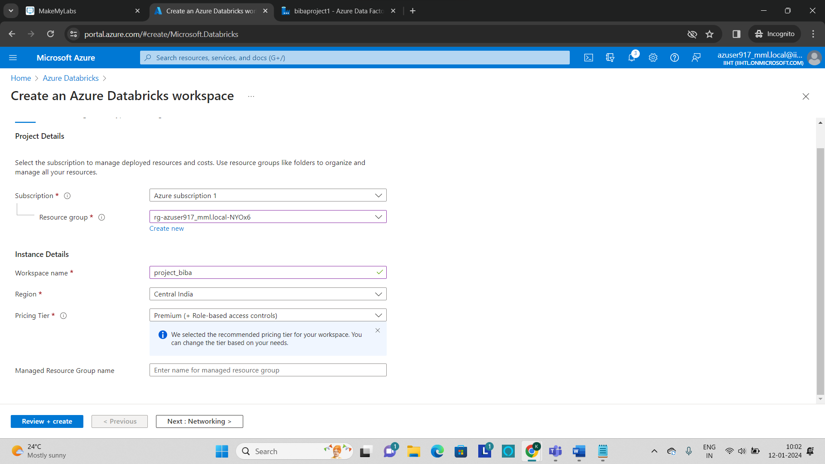

* **After the creation of workspace click on “launch workspace”.**

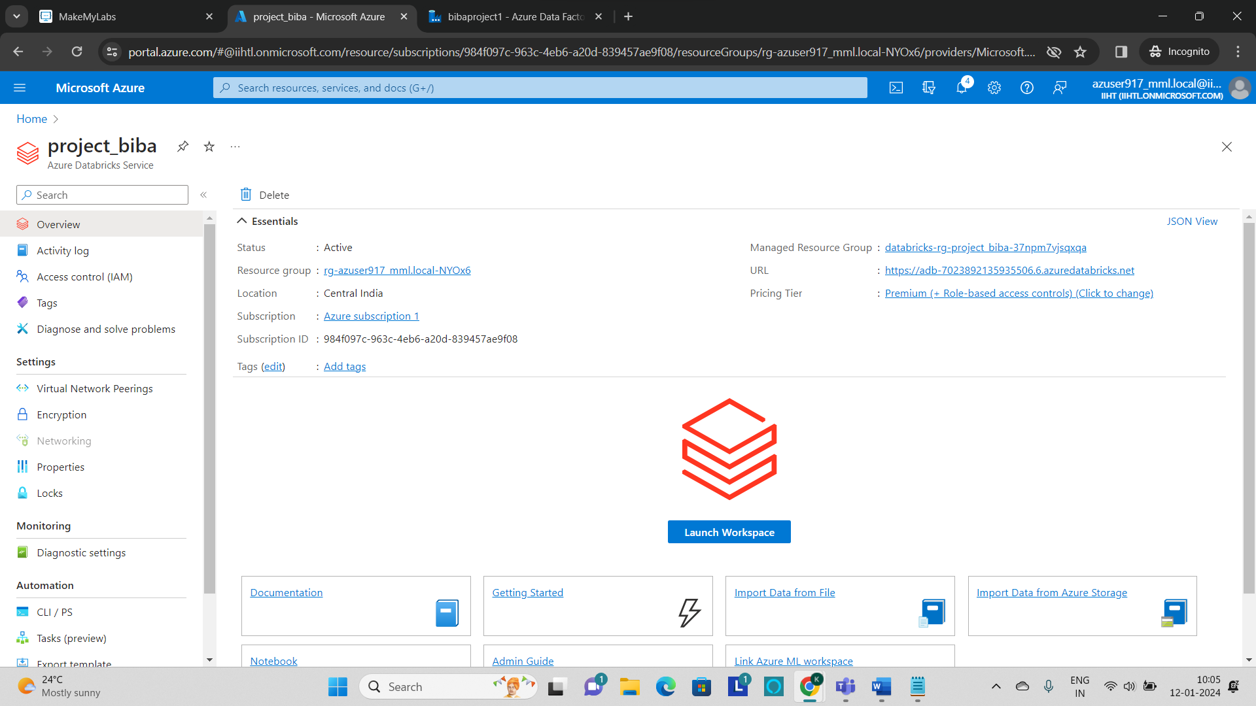

* **Create a cluster by clicking on the compute and then click on Create compute.**

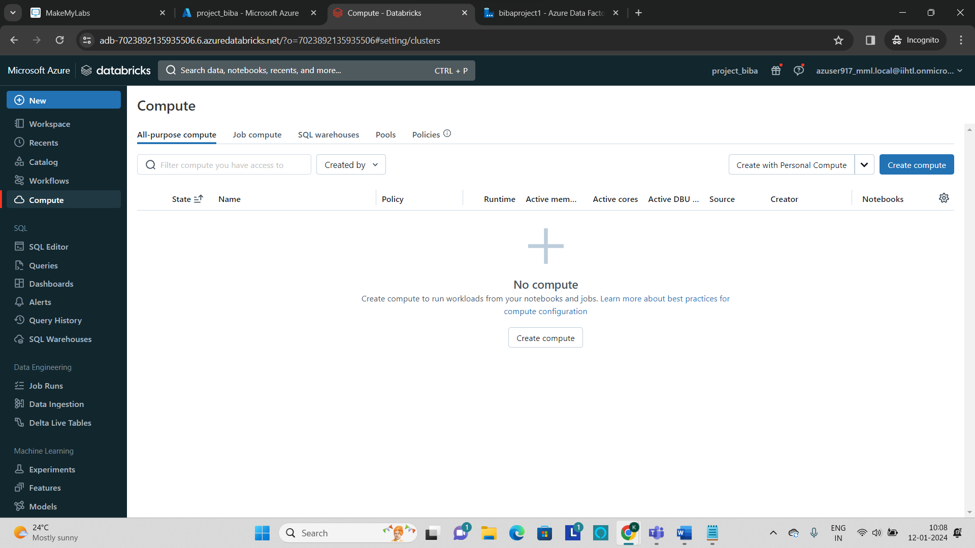

* **Fill out all the required information and click on Create Compute.**

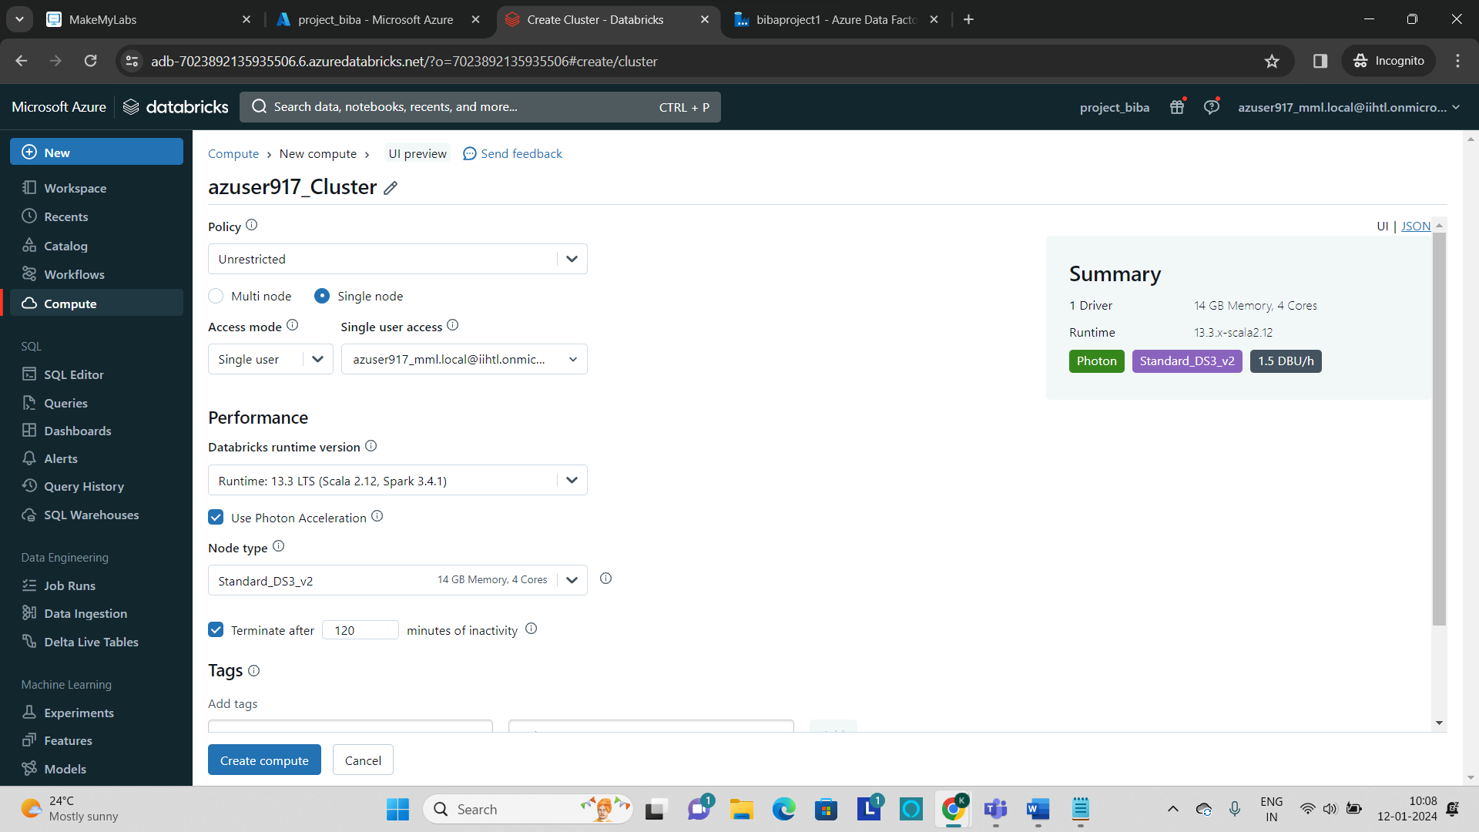

* **The cluster is created and ready to use as shown in the below.**

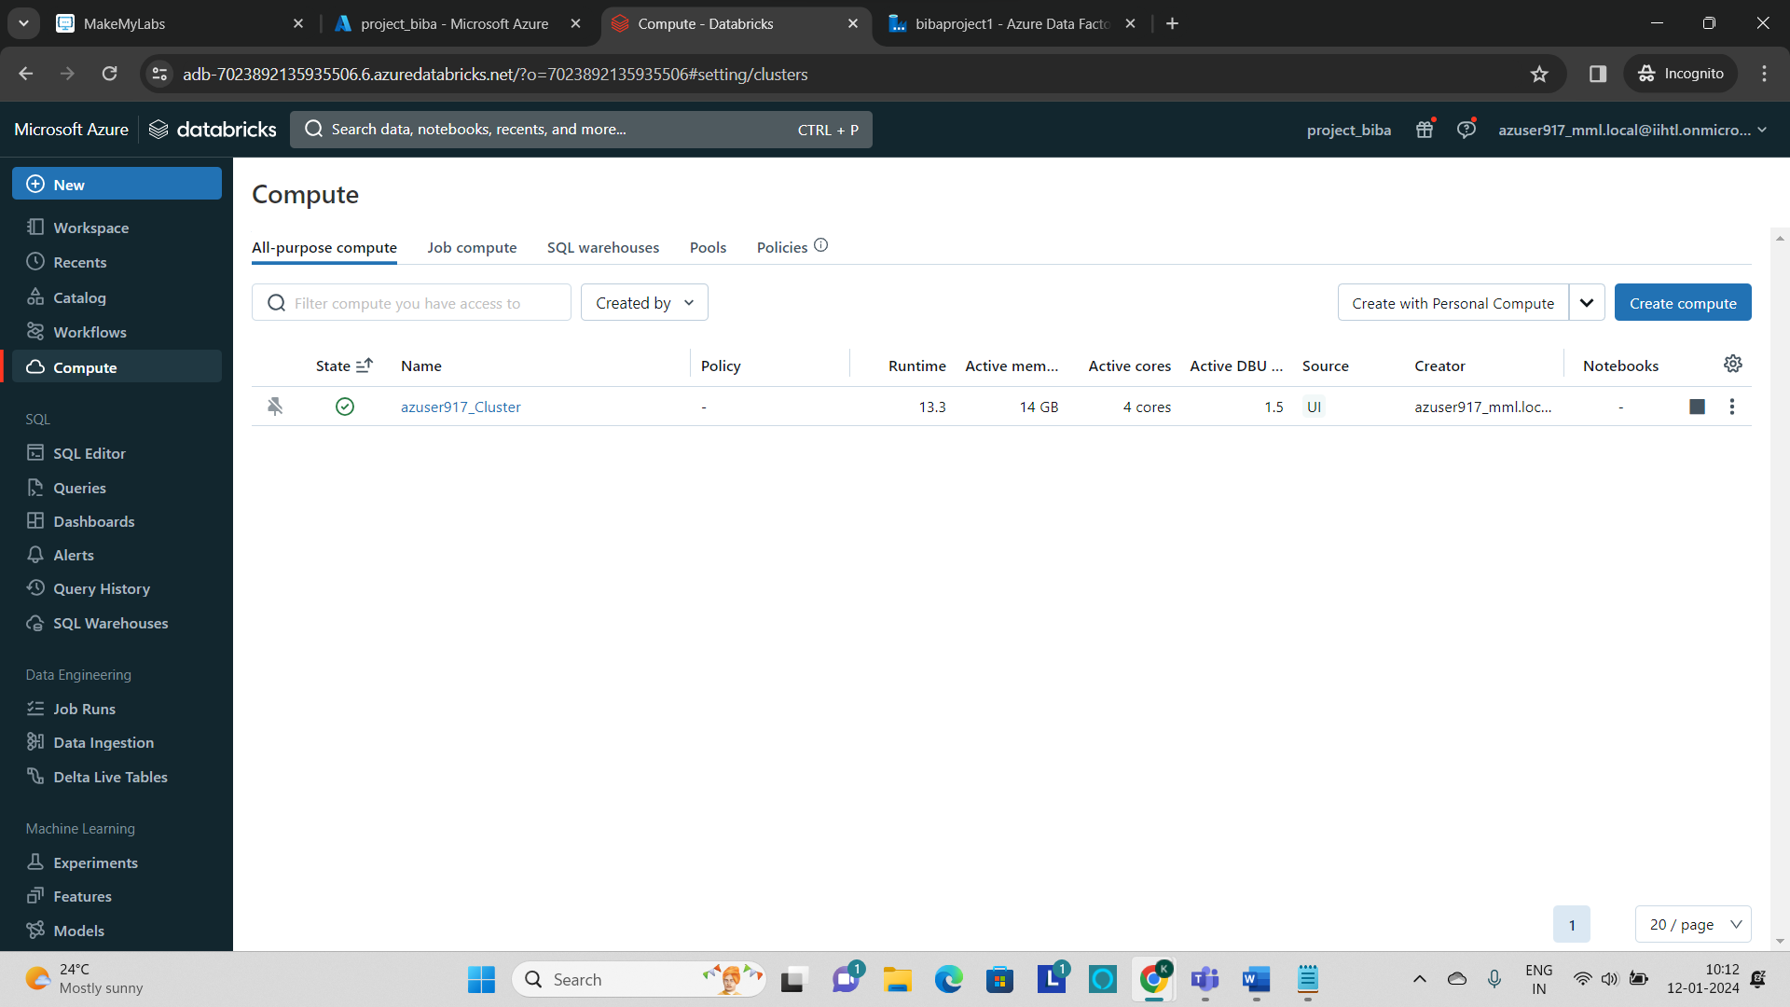

* **Create a Notebook to perform some of the transformations by using spark.**

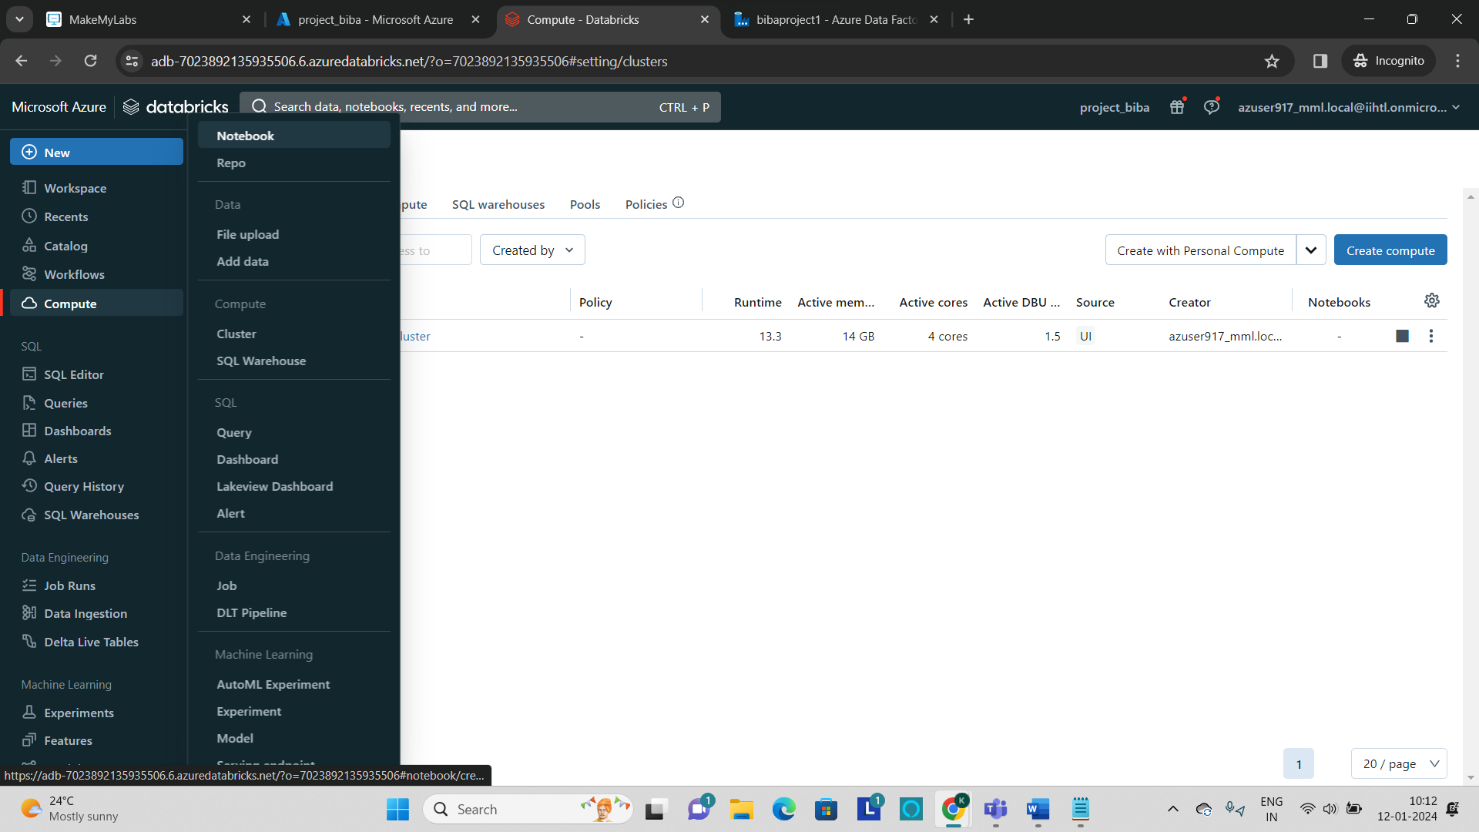

* **After the notebook is created, connect to the cluster by clicking and selecting the cluster which is been created in the previous step.**

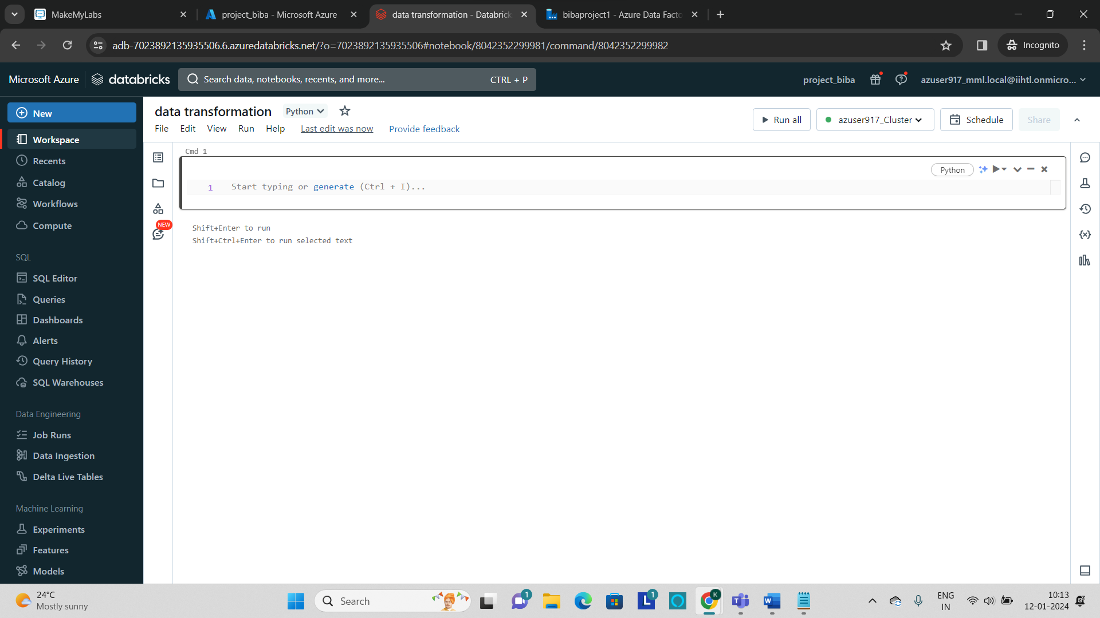

* **Now to mount the azure storage to the databricks use the below code and run in the notebook.**

**Code:**

**storage_account_name = "<storage account name>"**

**container_name = "<container name>"**

**mount_point = "/mnt/your_mount_point"**

**# Use the access key obtained in Step 1**

**storage_account_key= “<account_key>”**

**# Create the mount point**

**dbutils.fs.mkdirs(mount_point)**

**# Mount Azure Storage**

**dbutils.fs.mount(**

**source = f"wasbs://{container_name}@{storage_account_name}.blob.core.windows.net/",**

**mount_point = mount_point,**

**extra_configs={f"fs.azure.account.key.{storage_account_name}.blob.core.windows.net": storage_account_key}**

**)**

* **Now go to the storage account which is created at the beginning and click on “Access keys” to get the access key.**

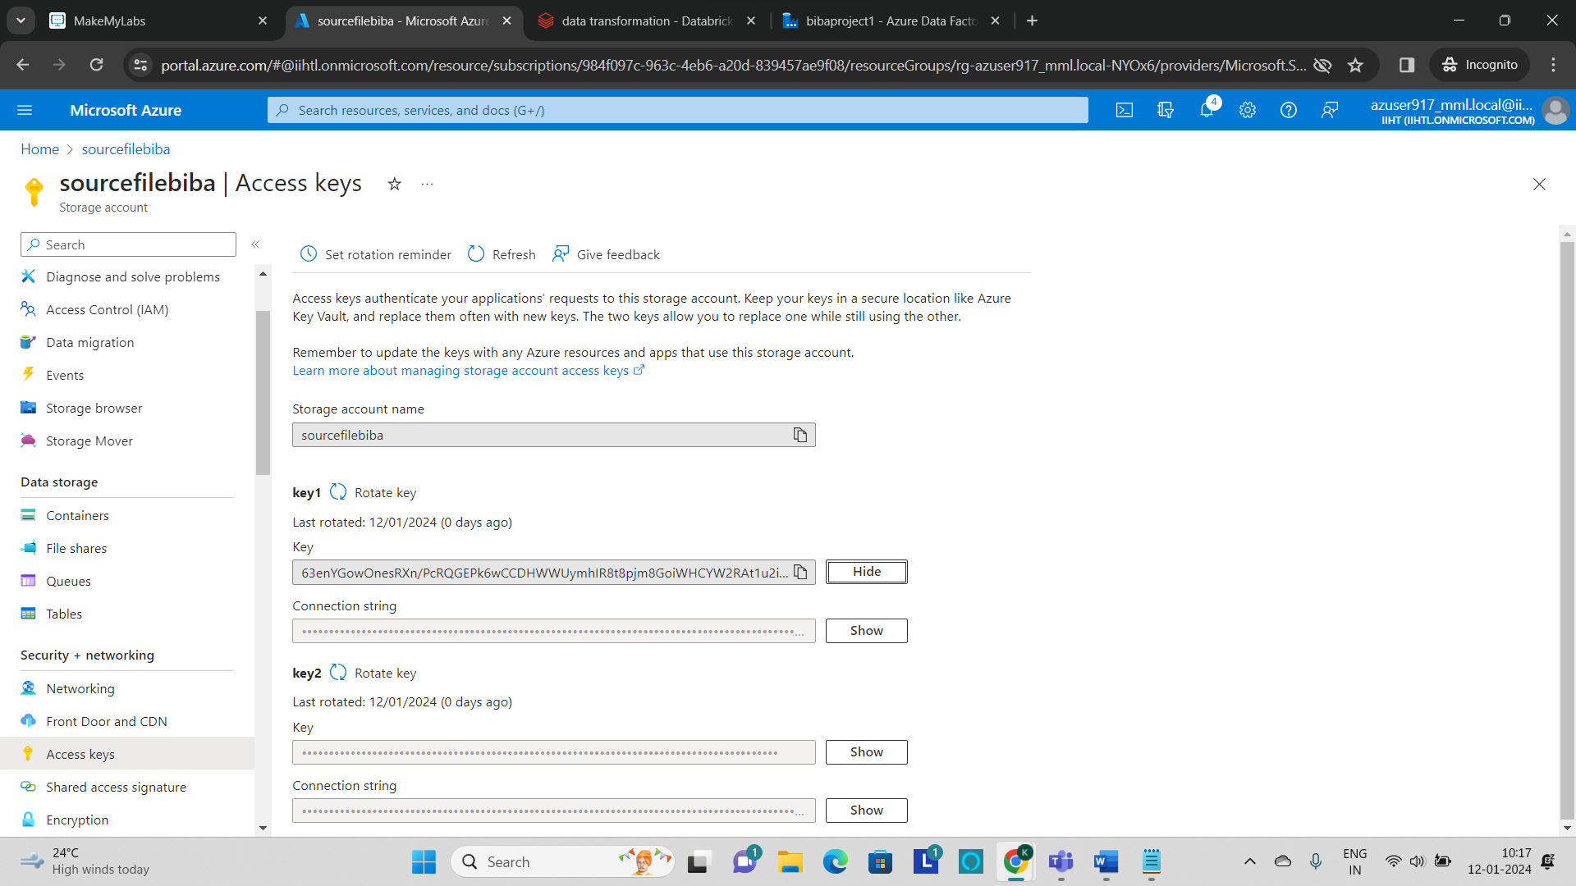

* Now paste the code in the cell and replace the **storage_account_name, Container_name, mount_point and storage_account_key.**

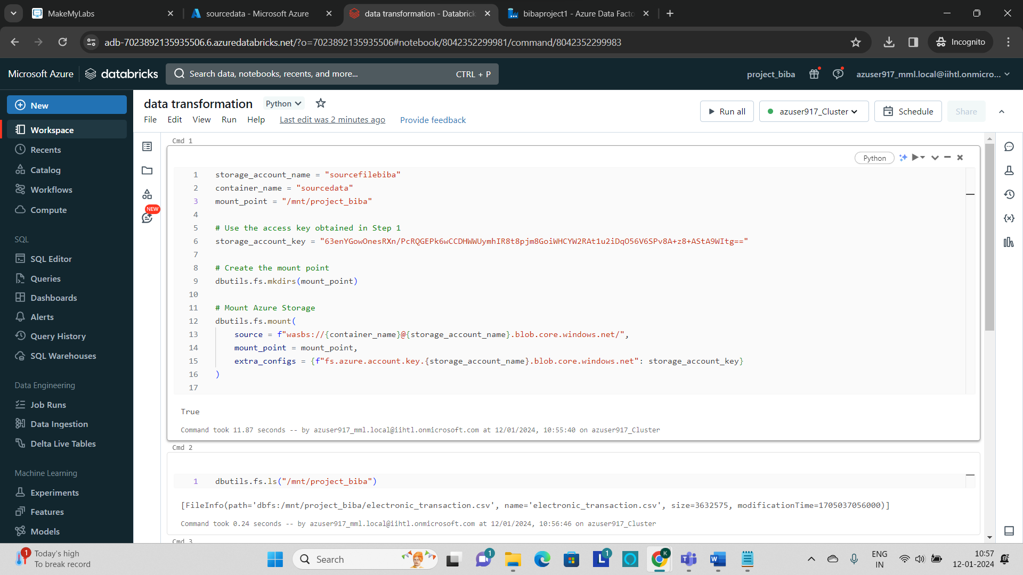

* Now click on run to execute the cell.
* To see the contents which are present in the storage account use **“dbutils.fs.ls(“mount_point”)”.**
* Now read the file by using the **“spark.read.load()”** command to the databricks.

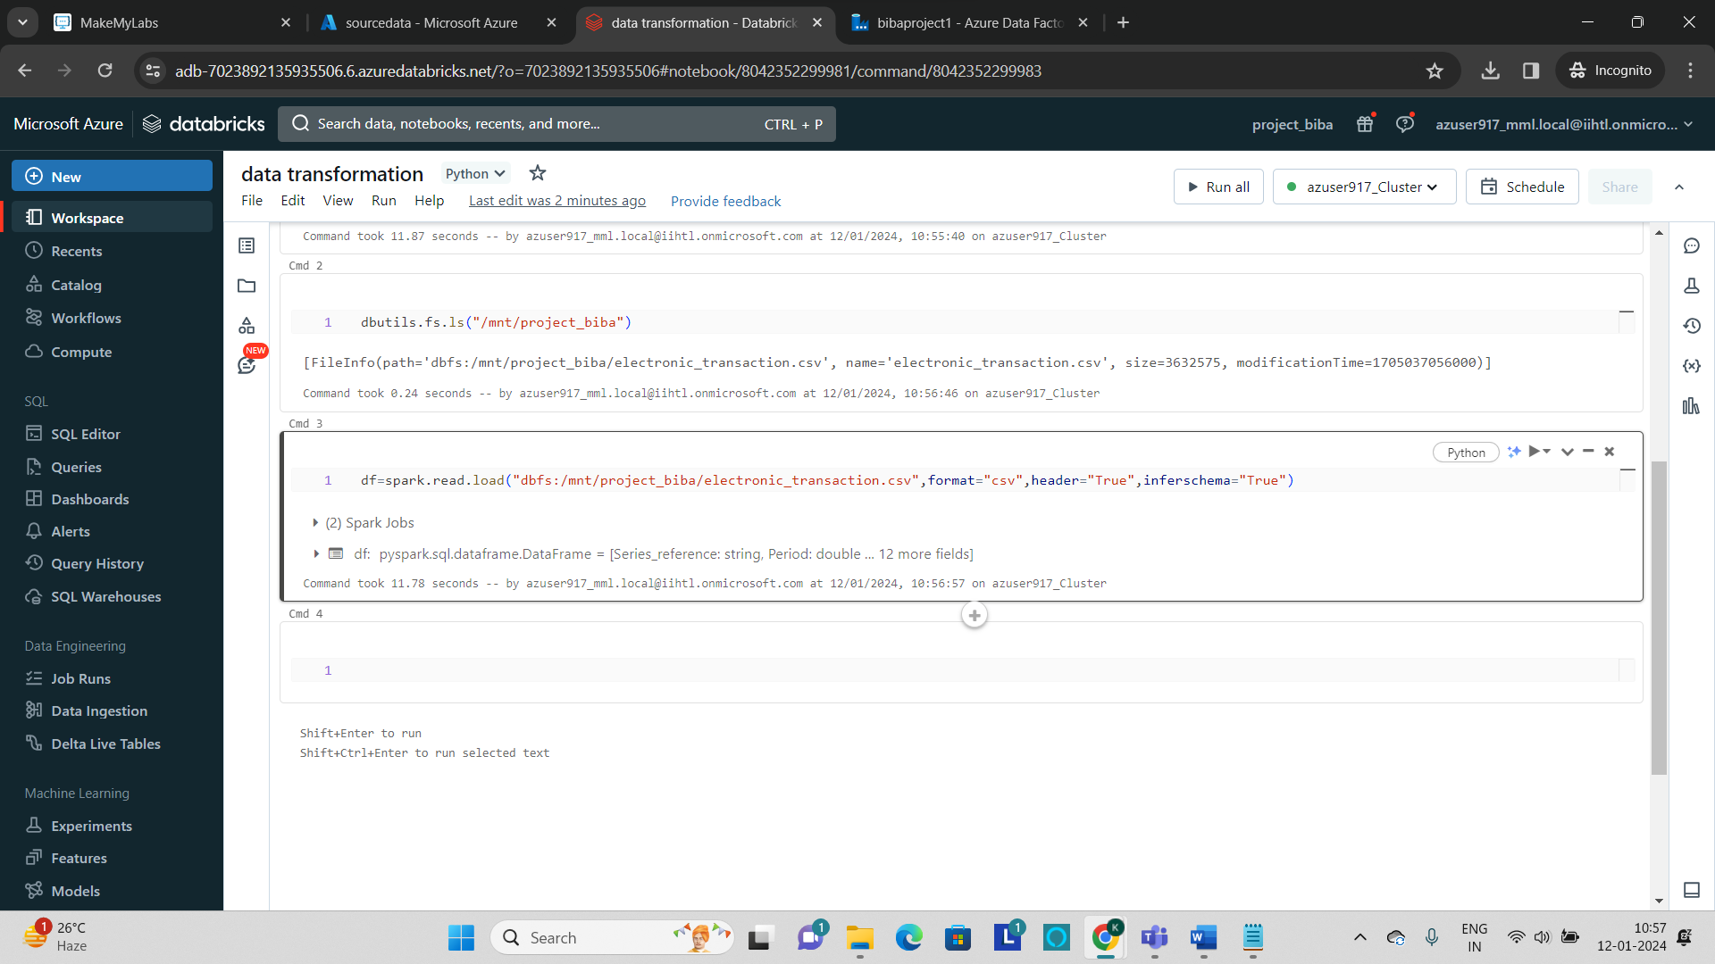

* **display()** is used to display the table

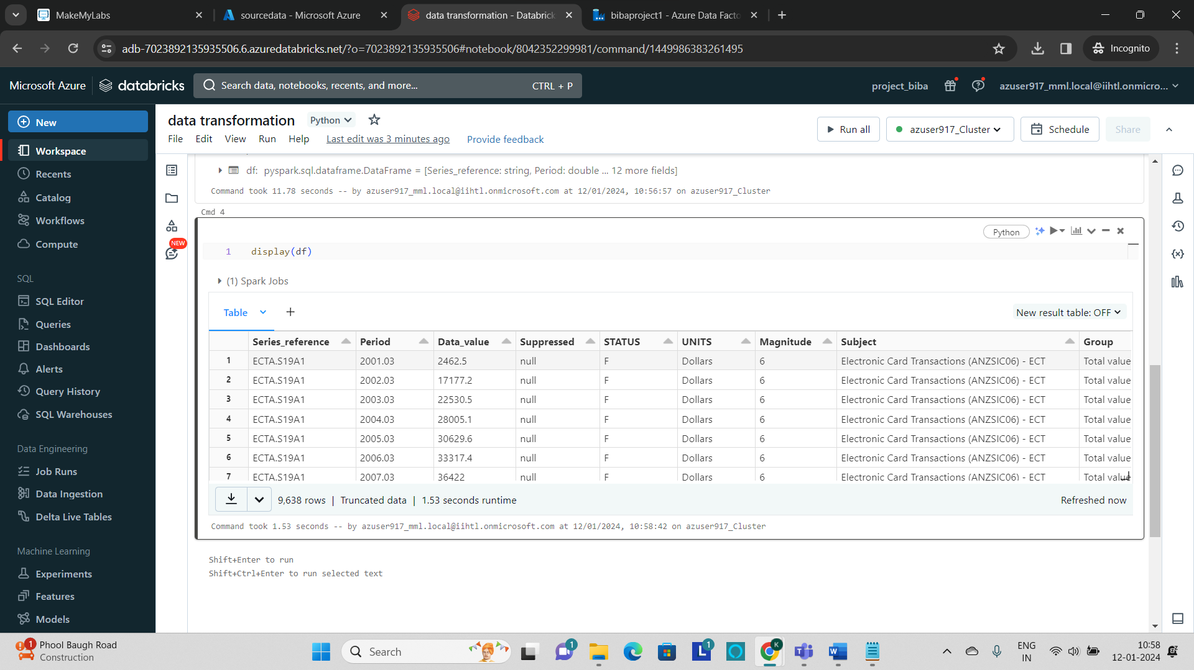

* Now run the code to perform the transformation to the data like selecting the **specific columns**, **filtering the data** and **counting the rows** and **deleting the unwanted columns.**

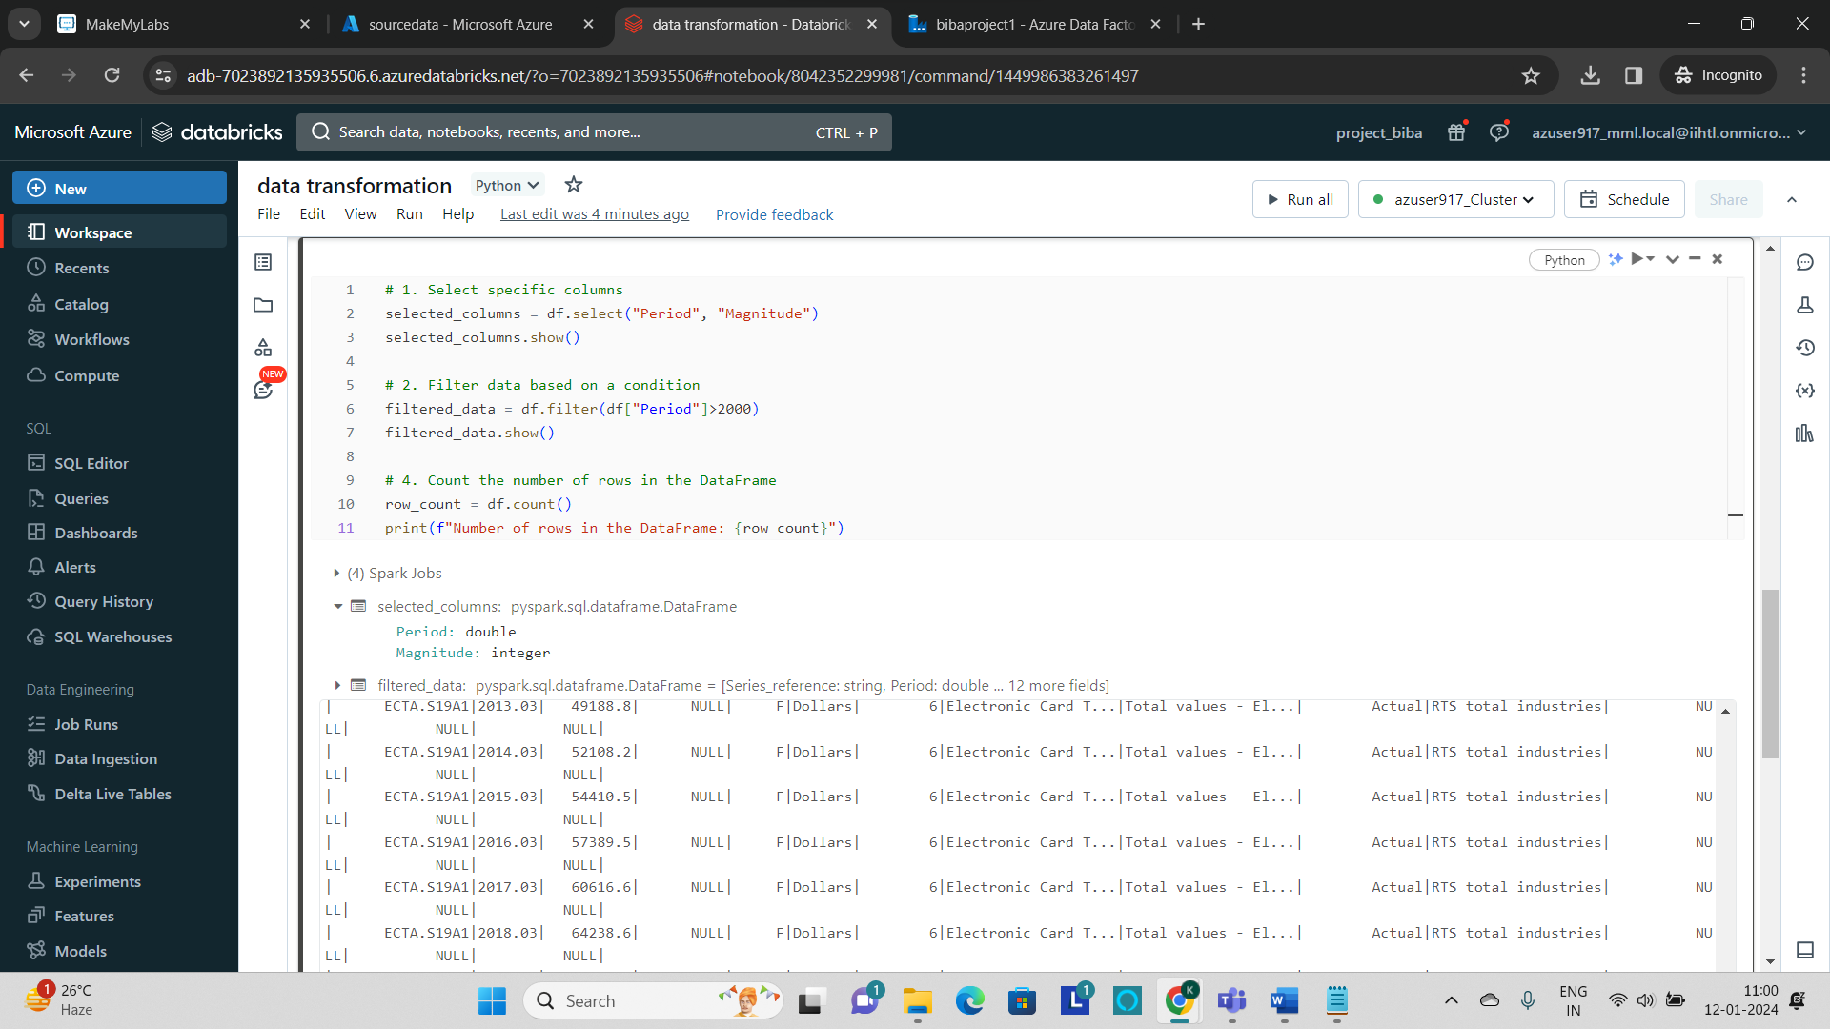

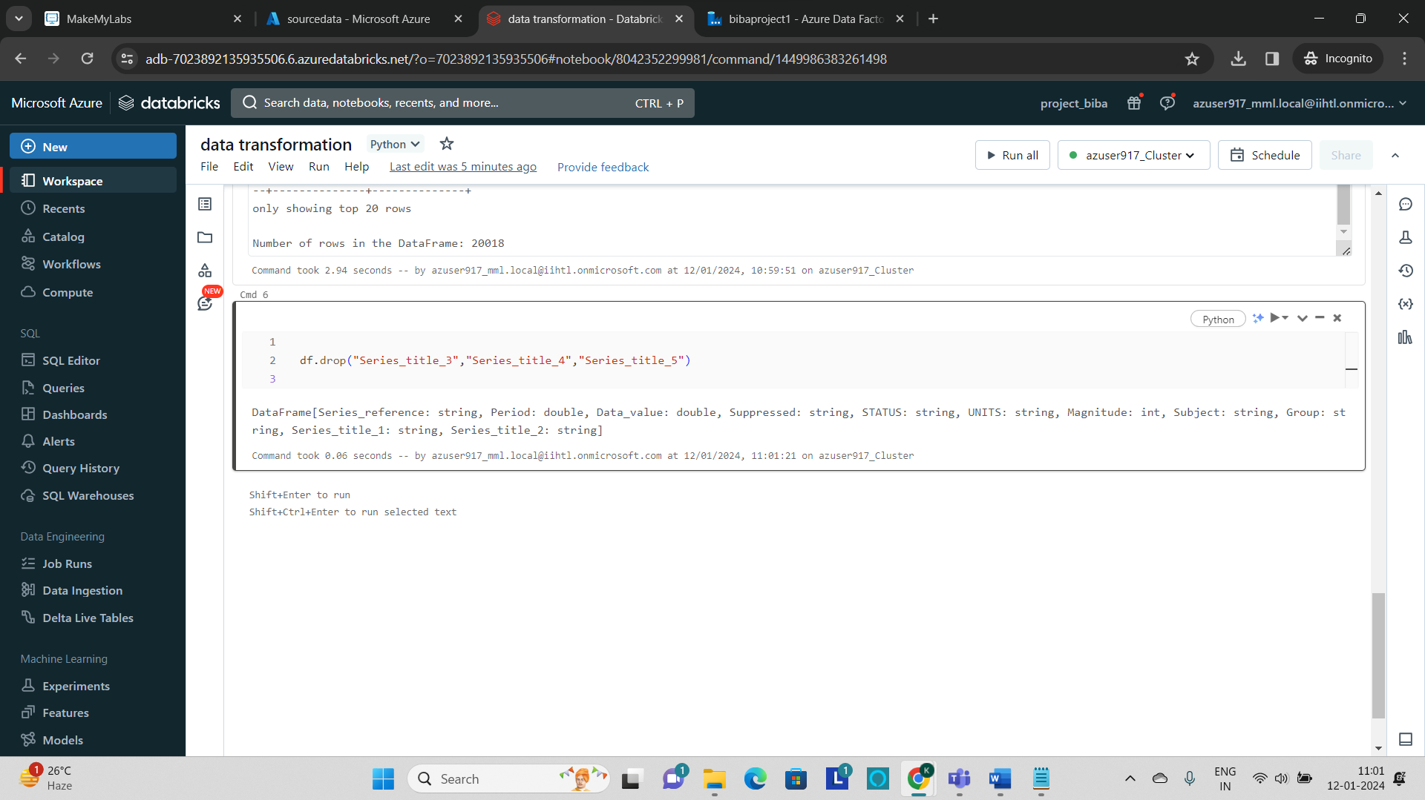

* Now after transforming the data, we need to **load the transformed data to the destination**.
* To perform that create **another storage account** in which the transformed file has to be loaded.
* Go to **storage account(classic)** and create a **storage** as shown in the previous.

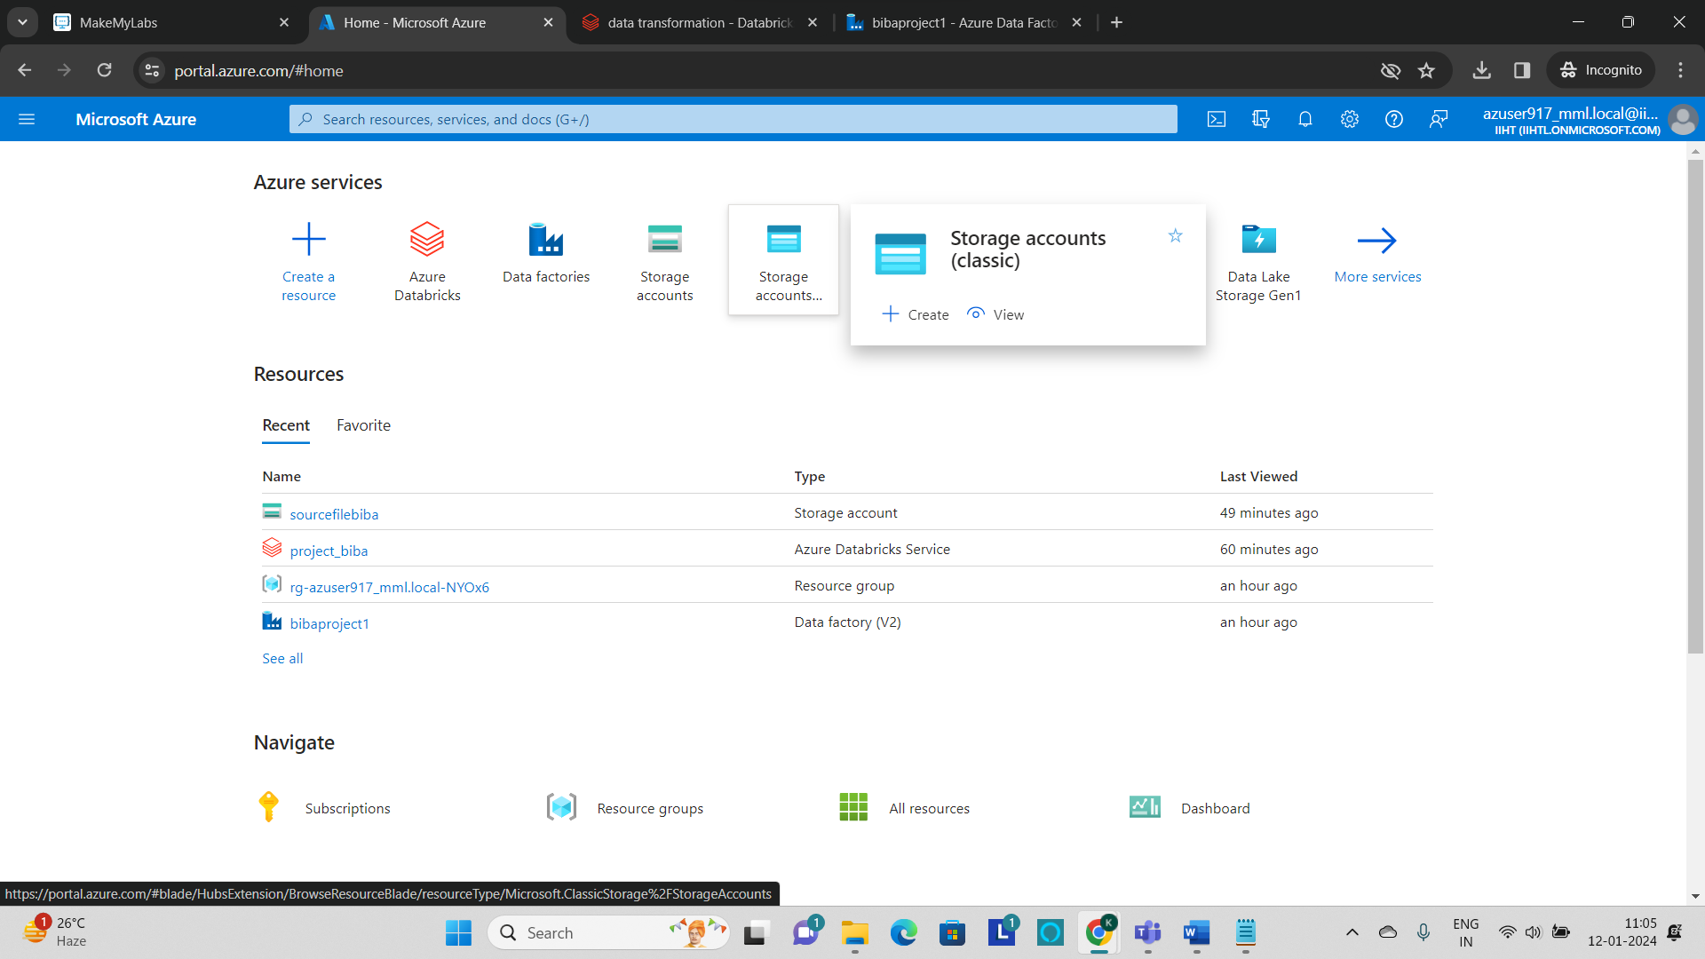

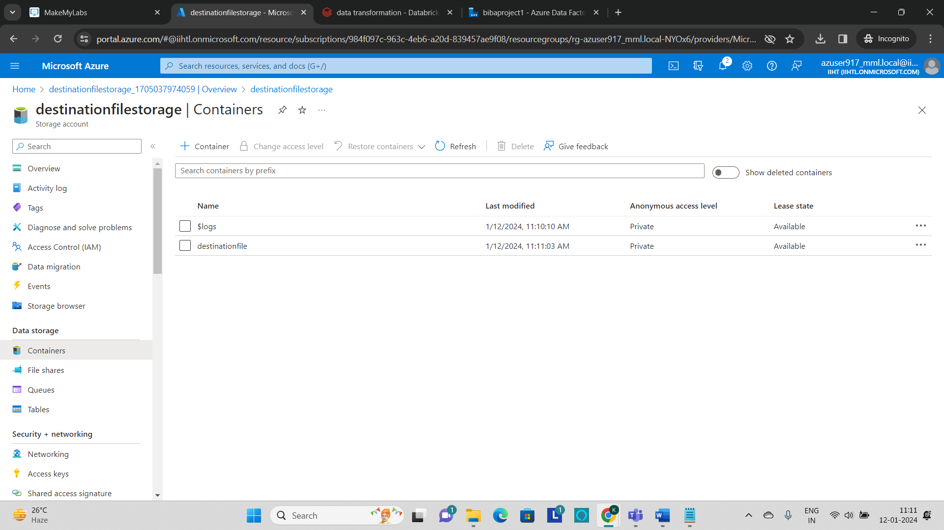

* The storage account named as **“destinationfilestorage”** and the container named as “destinationfile” is also created.
* Now mount the destination storage account to the databricks by using the same code which is used to mount the storage account in the previous step.
* Replace the **storage_account_name,** **Container_name,** **mount_point** and **storage_account_key** values with the newly created storage account.

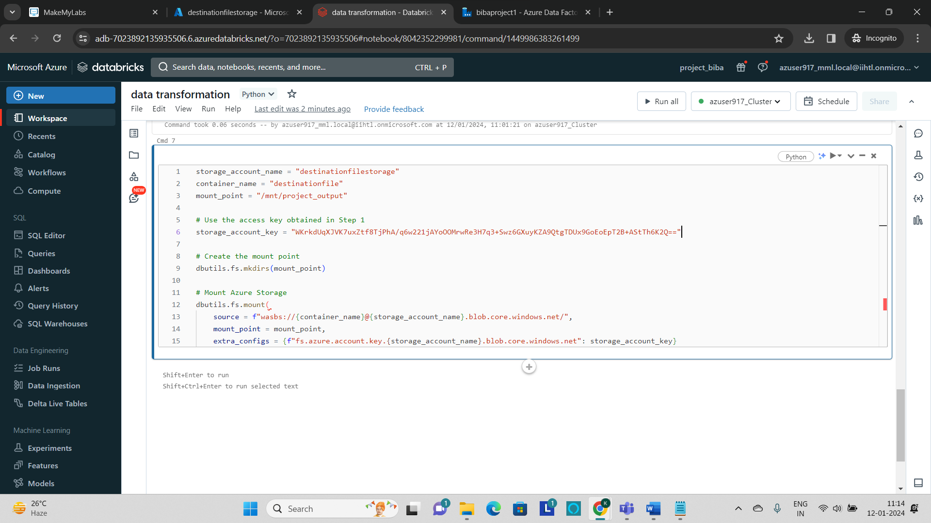

* To load the transformed file into the destination path, write the command as **df.write.mode(“overwrite”).csv(“path”)**

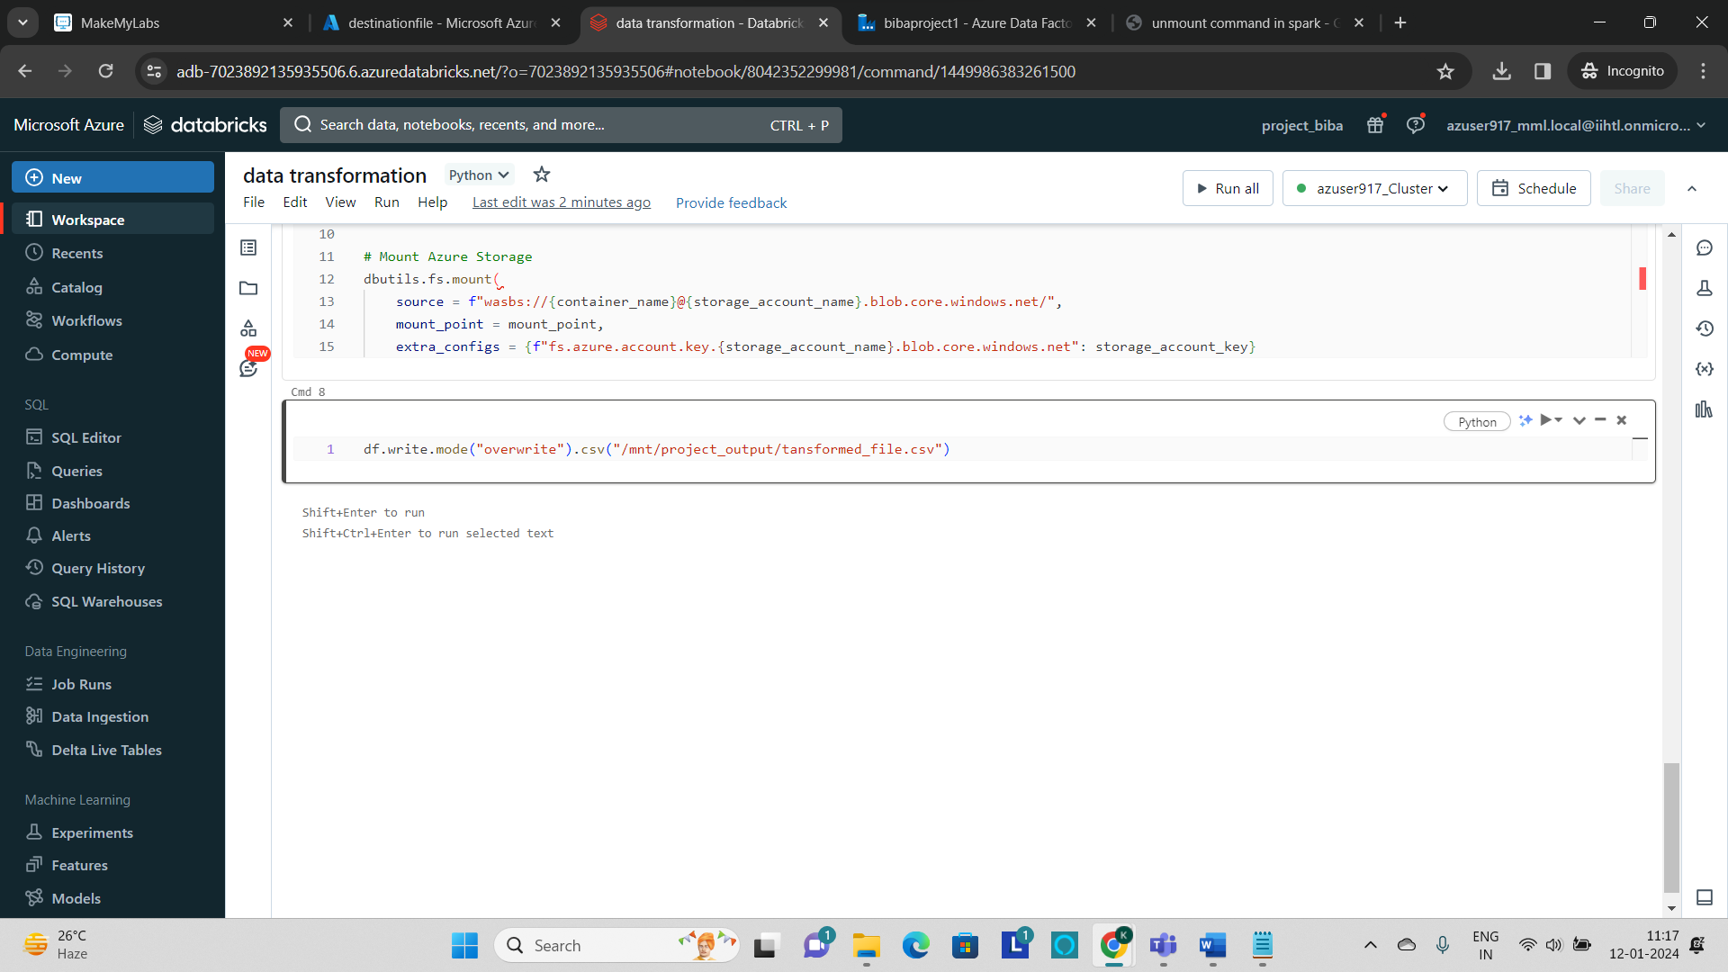

* **dbutils.fs.unmount(“mount_point”)** commandis used in the beginning cell to unmount and undo all the runs which are performed in the notebook. This is performed to eliminate the errors while running the notebook activity in the azure data factory.

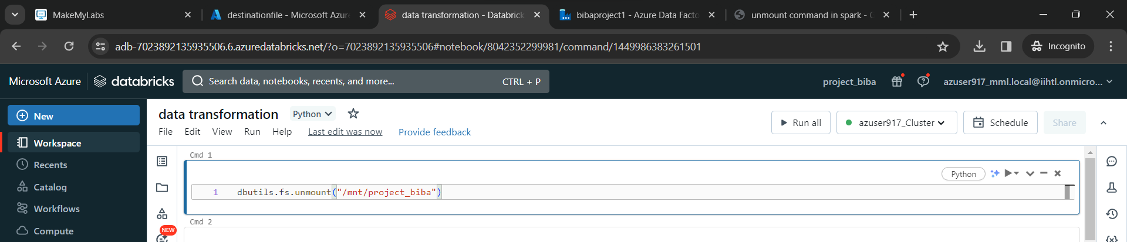

**Step3: Integrating ADF with ADB**

* To perform this, go to azure data factory and in that go to **manage tab** and create a **linked service.**

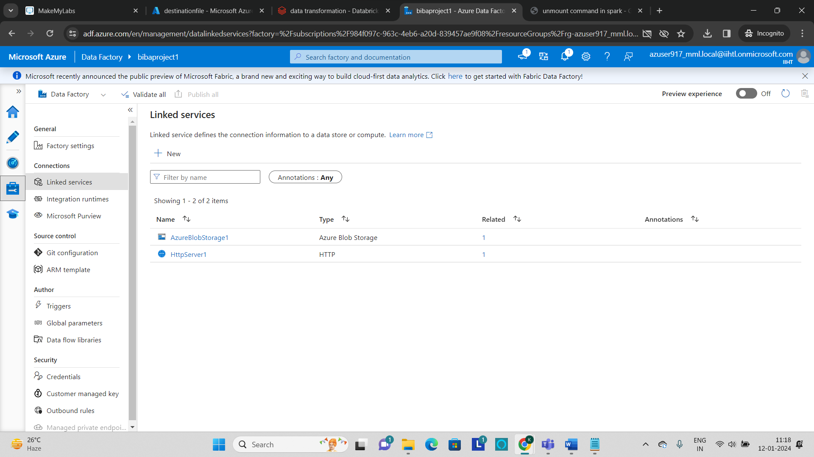

* Click on **“+New”** to create a linked service.

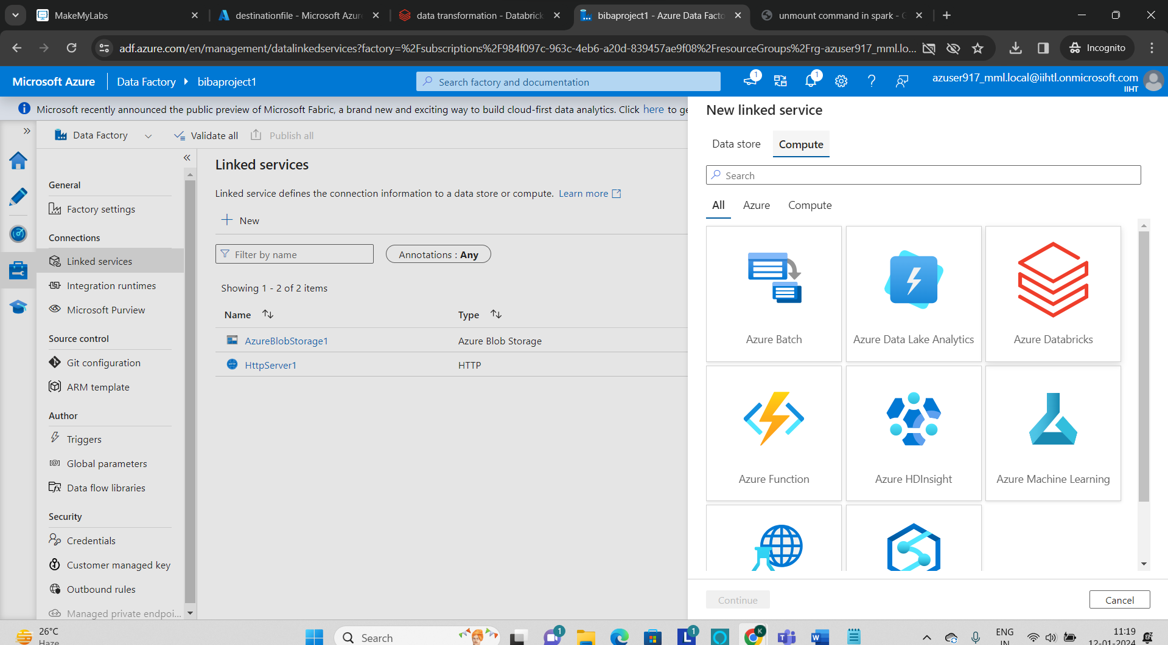

* Select **Azure Databricks** and then to create **azure databricks linked service** we need the access token.
* To get the **access token**, go to **azure databricks** and click on **profile** and in the drop-down click on **user settings**.
* In the user settings go to developer options and click on **Manage** which is in the Access tokens.

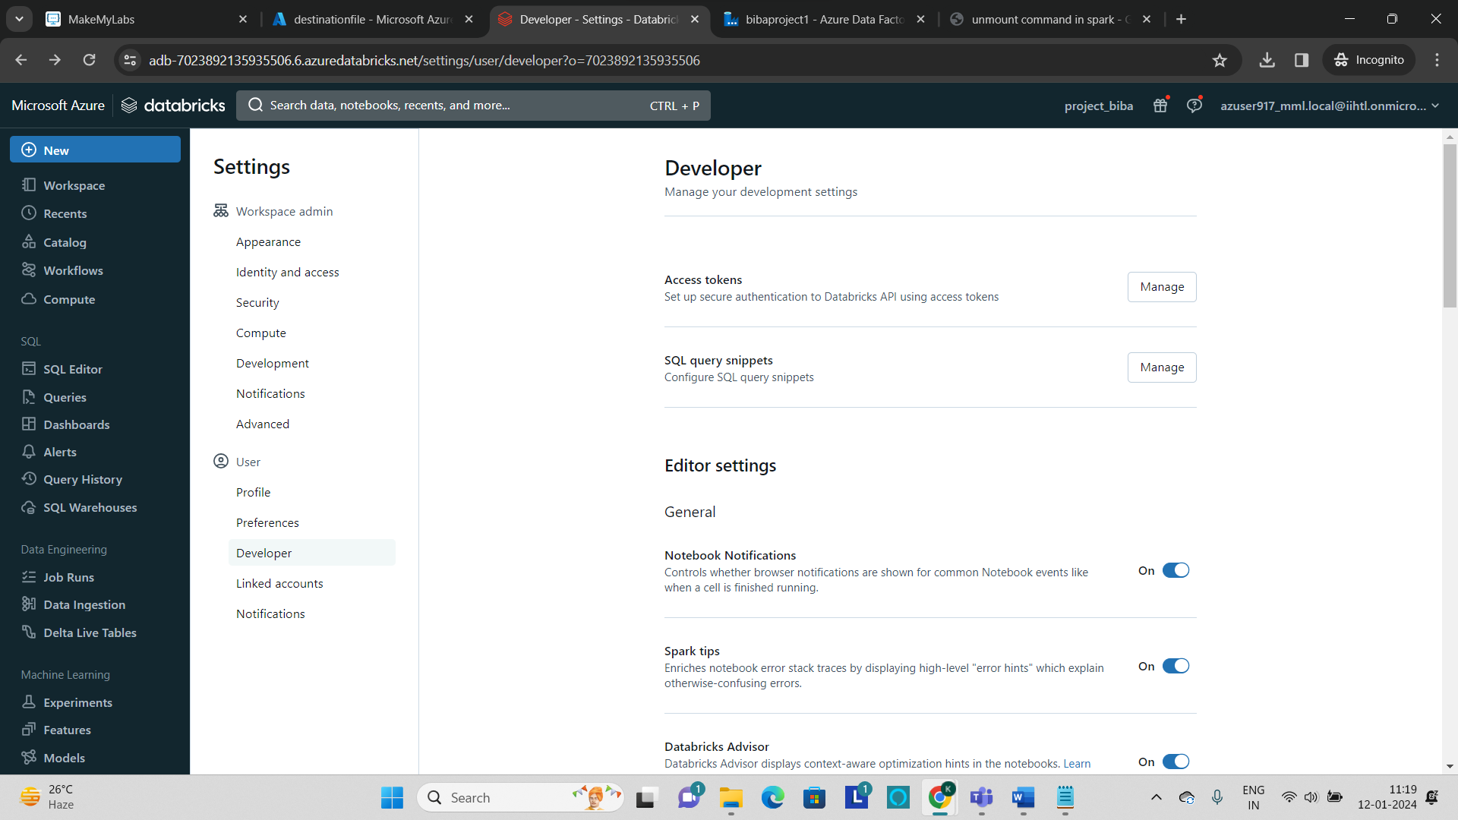

* Click on **“Generate New token”** and it will generate a new token.

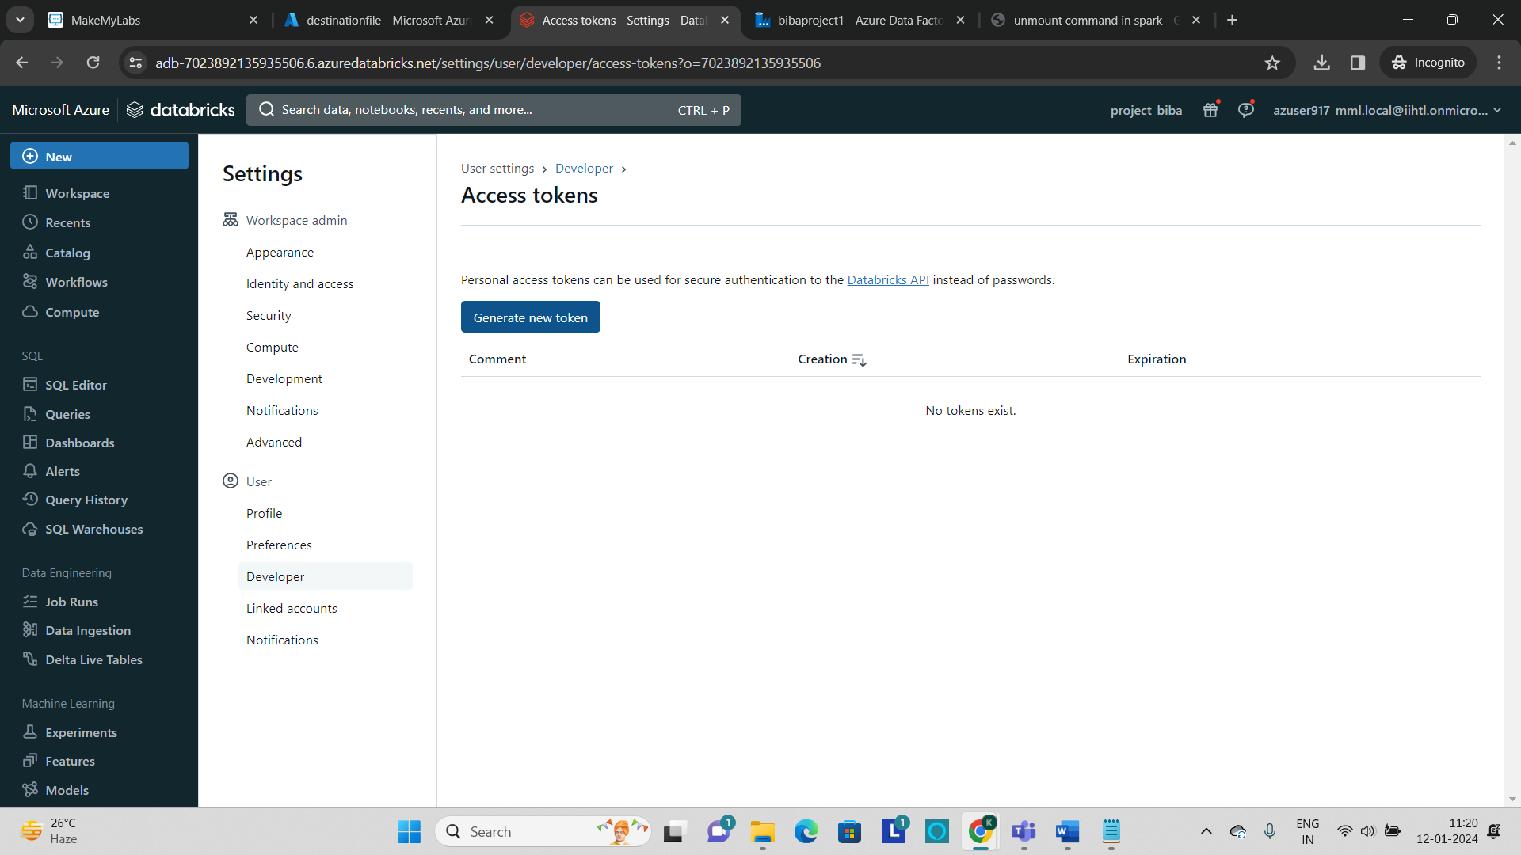

* The generated token will be displayed and copy that and paste it in the azuredatabricks linked service to create.

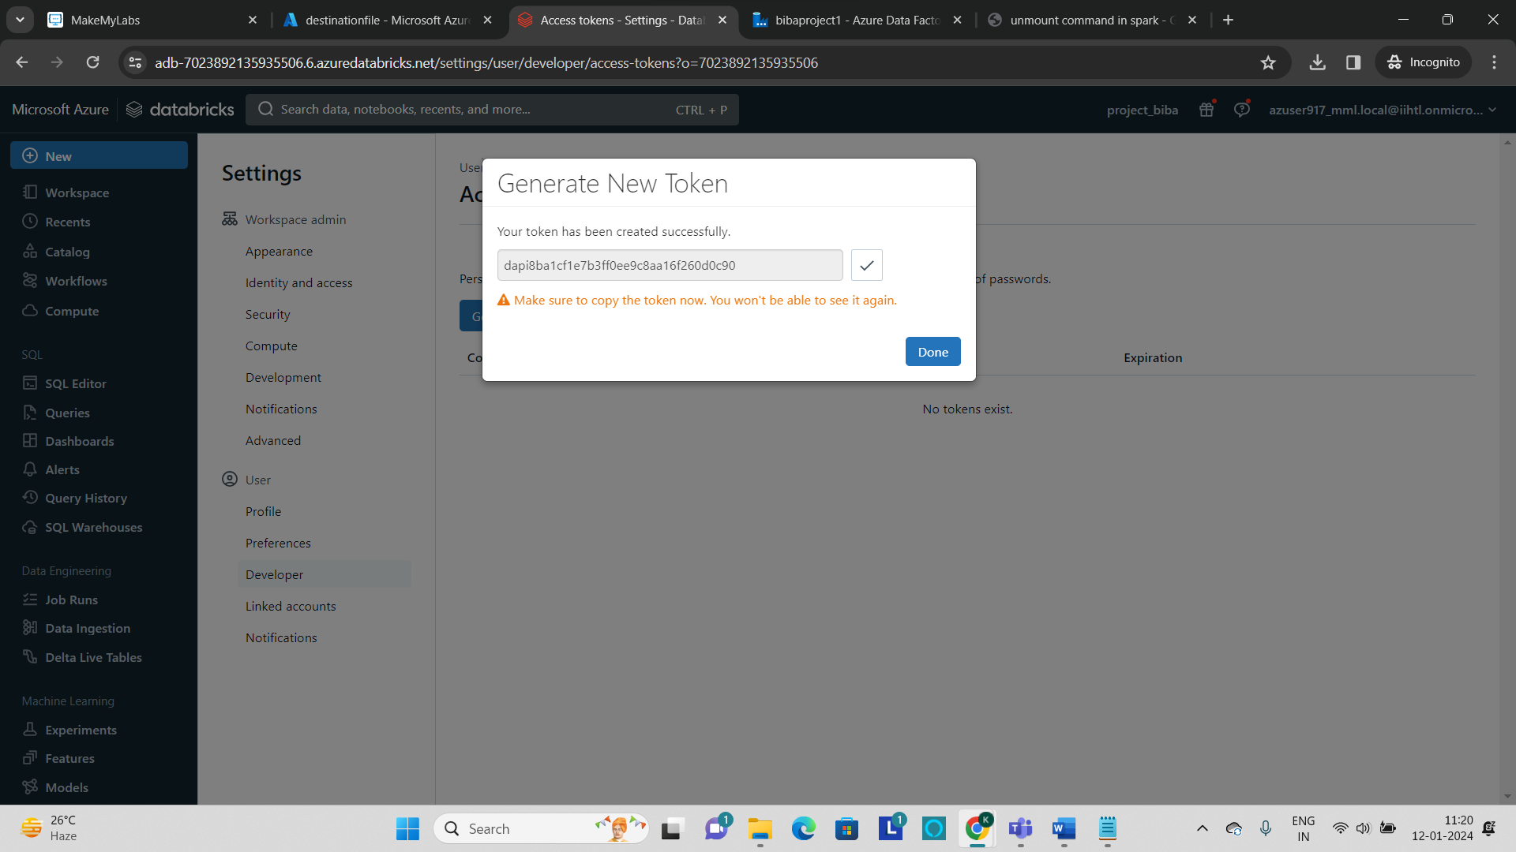

* Select the **Azure subscription**, **Databricks workspace** and select **“Existing interactive cluster”** which will help to select the existing cluster.

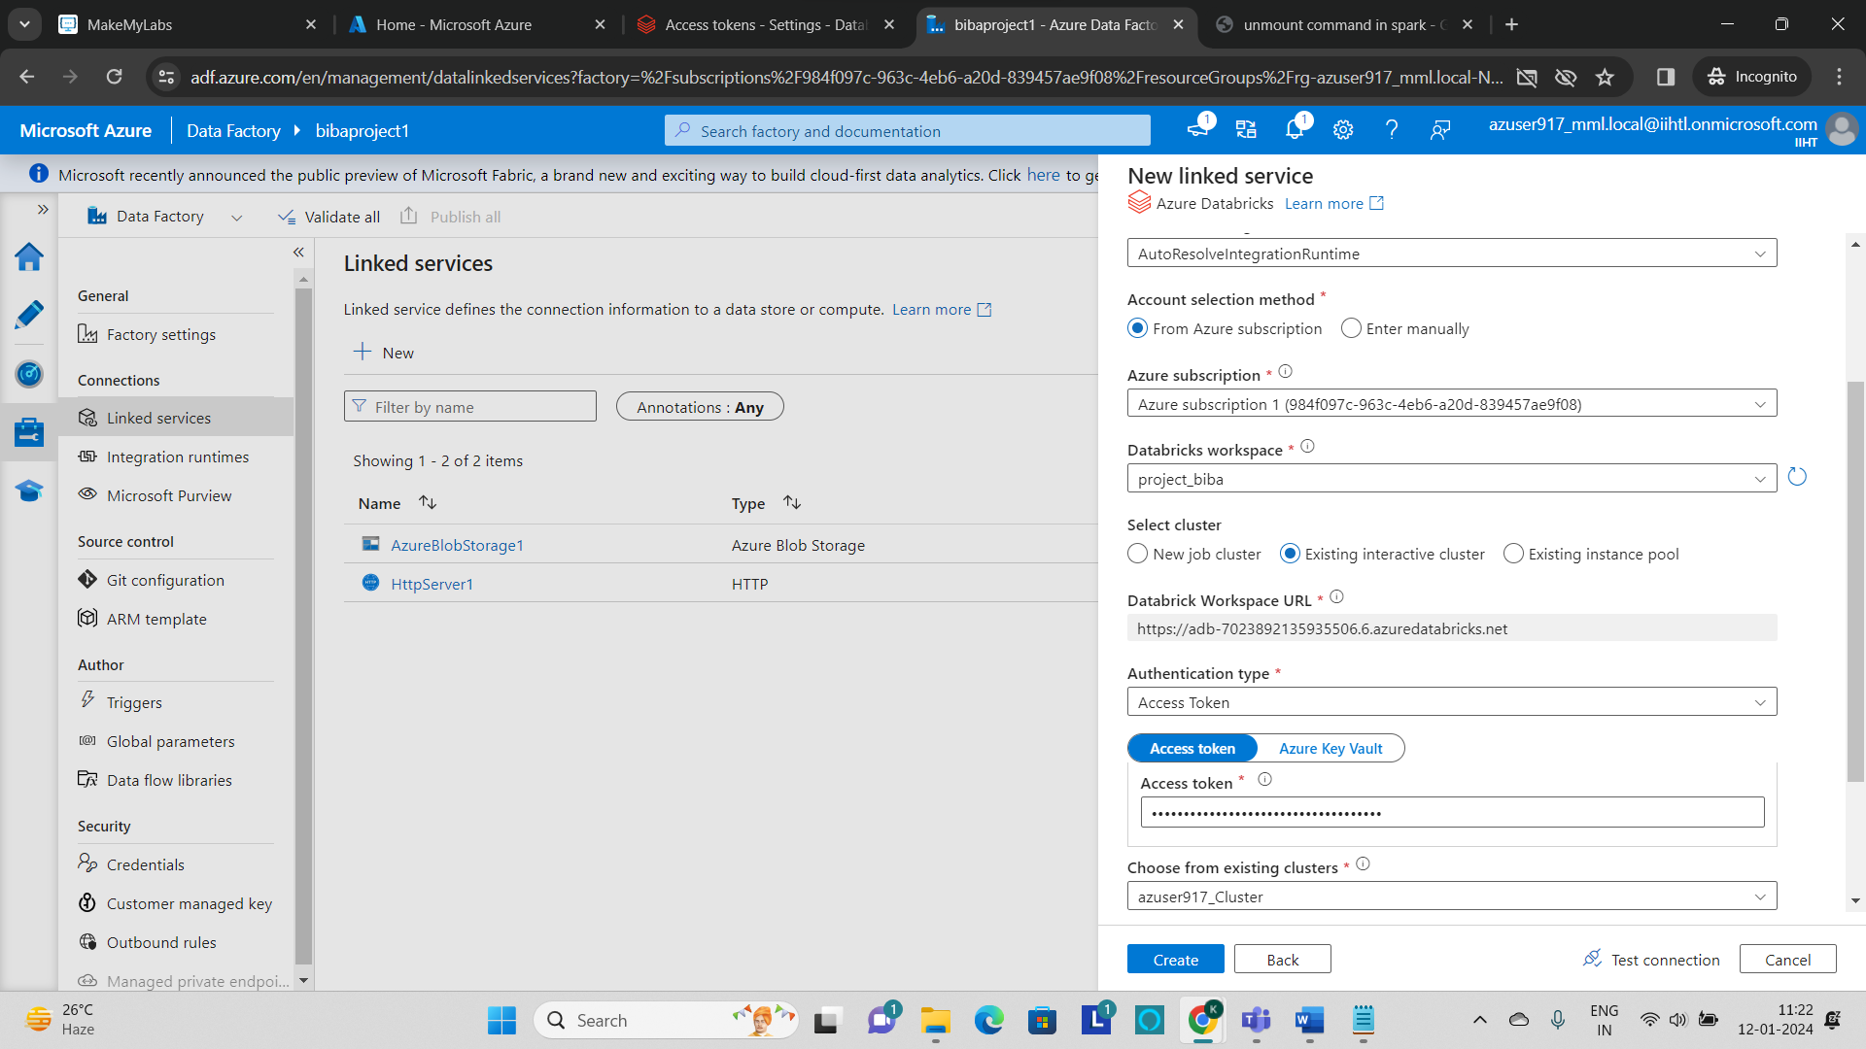

* Now test the connection and click on **“create”.**
* Now the Azure databricks linked service has been created.

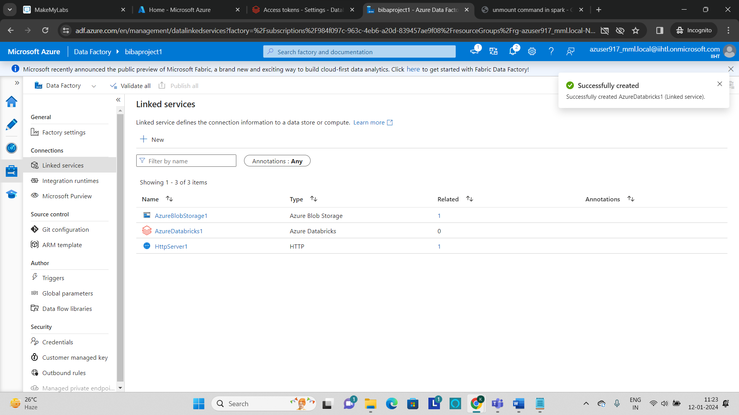

* Go to **Author tab** and under the **activities** Section go to **databricks** and drag **the Notebook** to the pipeline workspace.

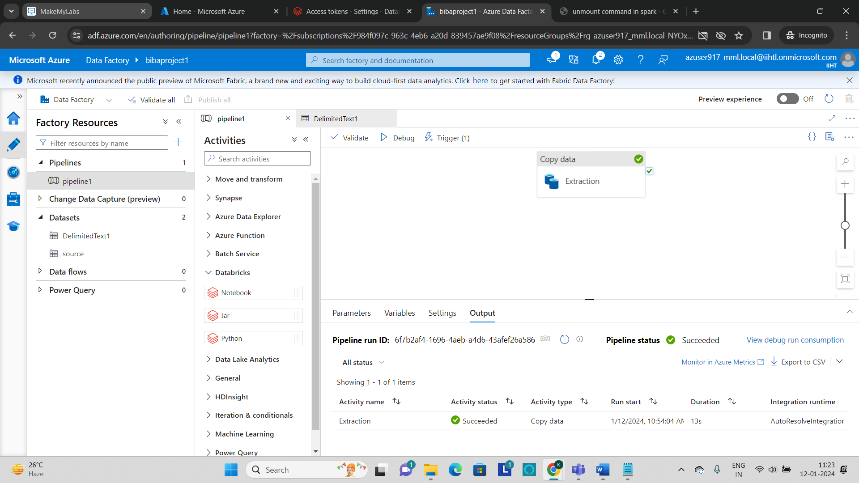

* Now connect the **copy activity** and the **databricks notebook.**

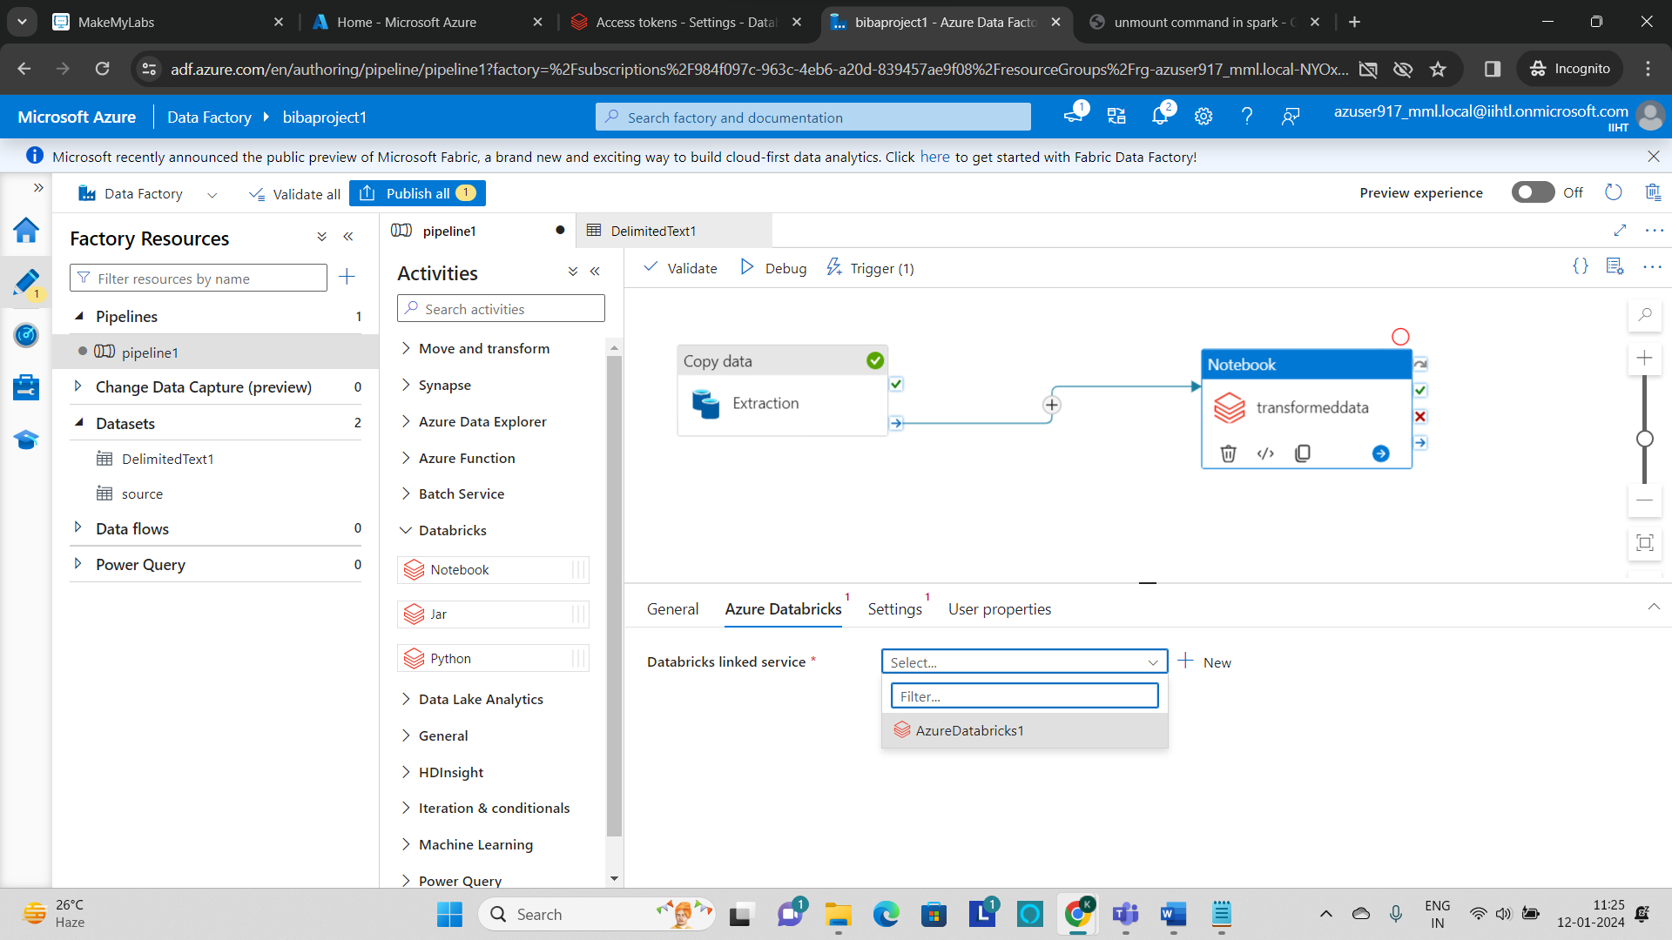

* Give the name for the notebook1 as **“transformeddata”** and select the **‘AzureDatabricks1’** as a linked service.
* In the settings browse the path of the notebook.

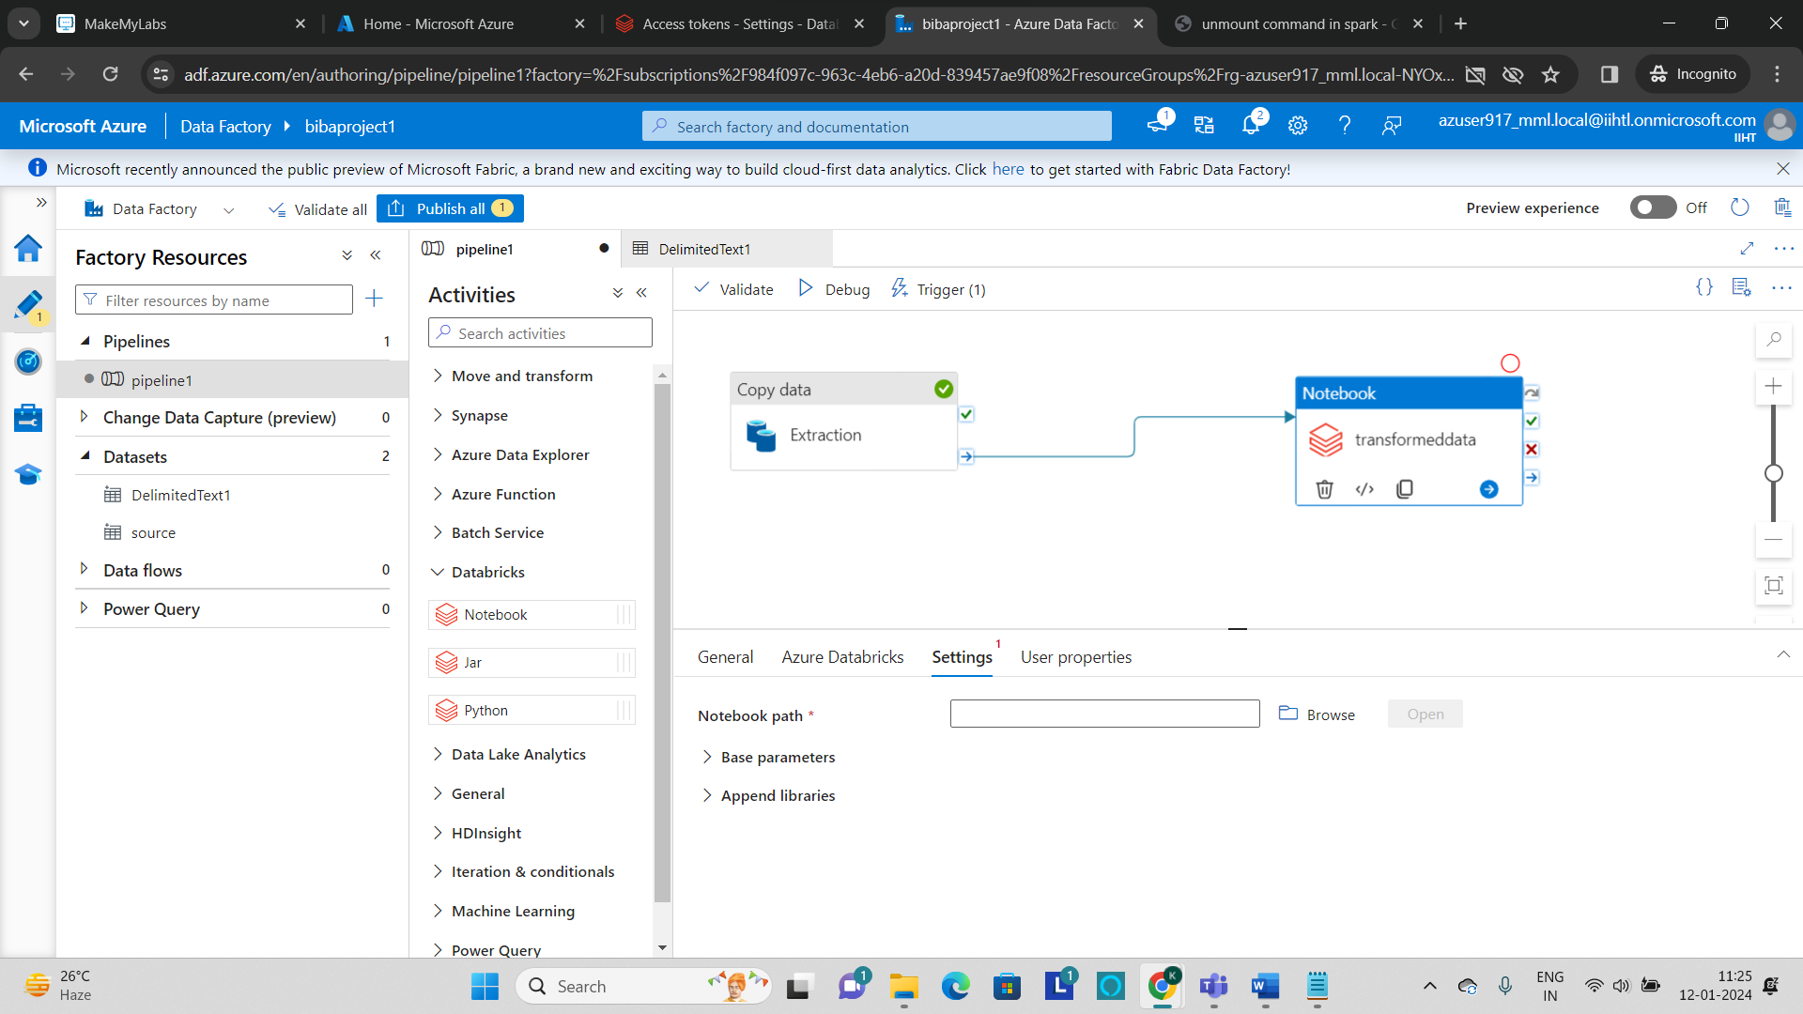

* After successfully setting up the path of the notebook, validate the notebook and you can run the notebook on the existing trigger.
* Click on **“Debug”** to run the pipeline.
* We can **monitor** the running status of the pipeline in the output section.
* The pipeline is executed successfully as shown below and you can verify the transformed file is present in the **destination storage** or not.

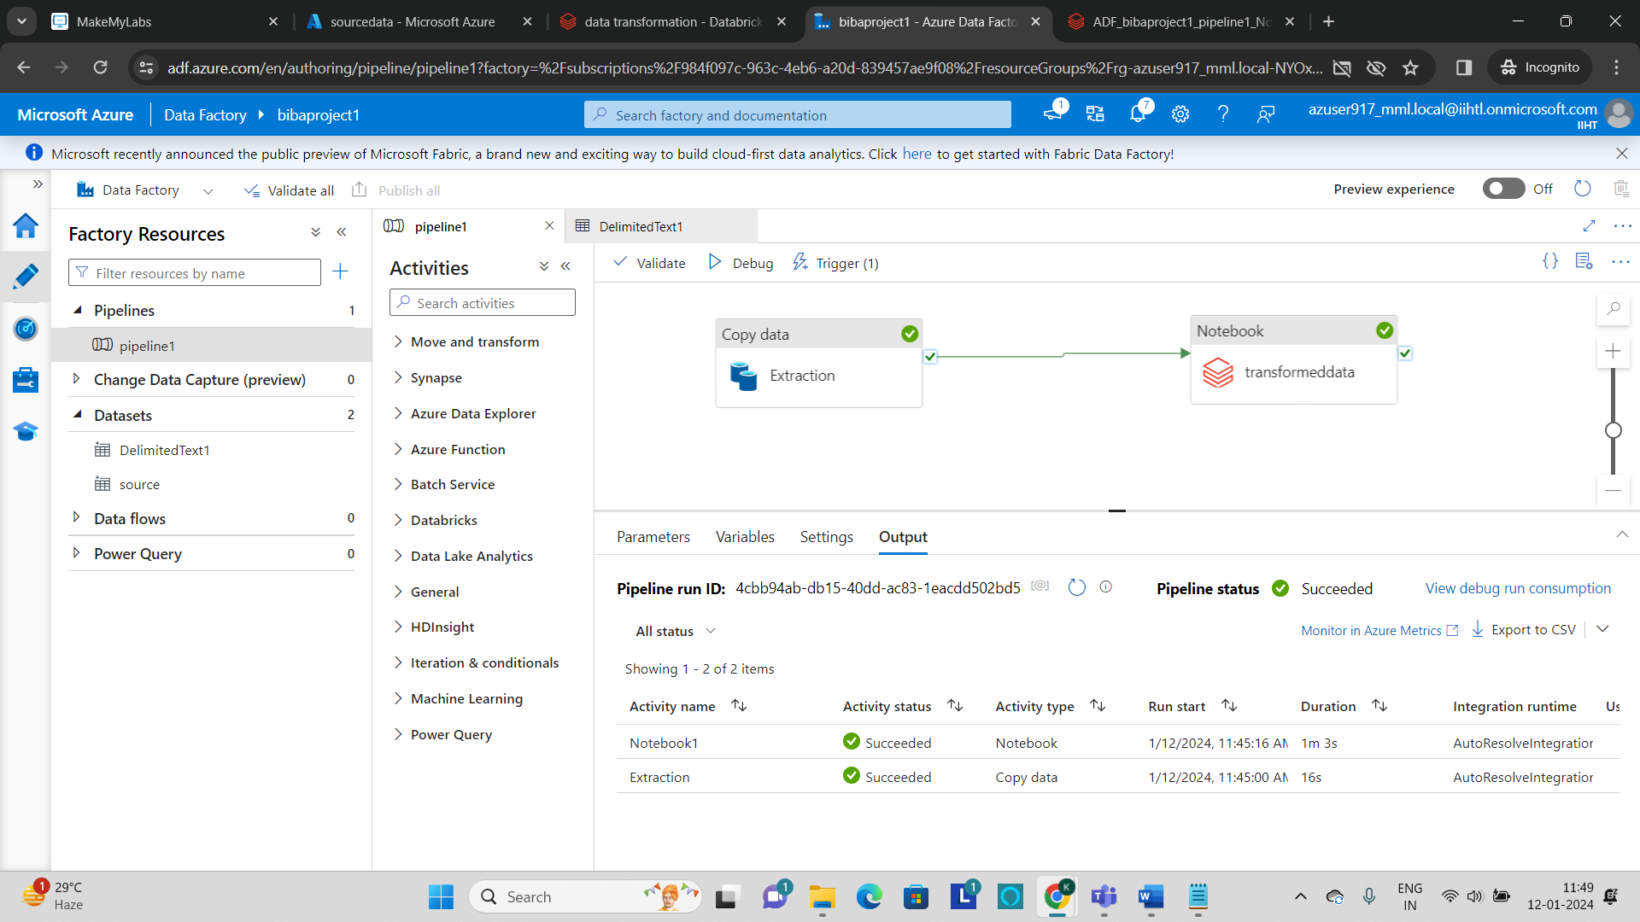

**Output:**

The output csv file is present in the destinationfile storage account which is provided as a destination to load the transformed csv file.

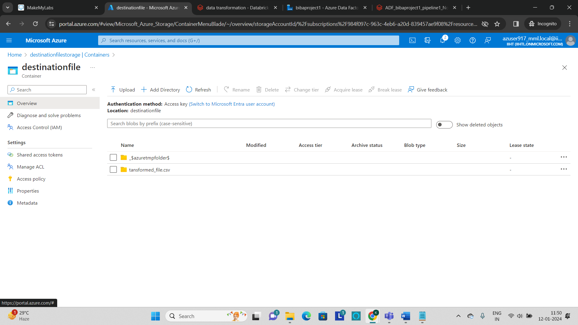

* The files which are loaded into the destination storage is shown in the below image.

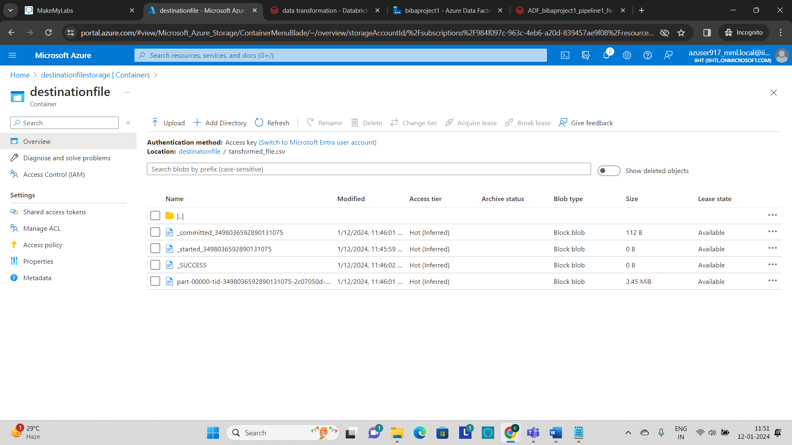

* We can also download the transformed file into the local system and can view the transformations that are made to the source file.

